

Introduction To Wikis

A QA Focus Briefing Document

Background
Wiki technologies are increasingly being used to support development work across distributed teams. This document aims to give a brief description of Wikis and to summarise the main challenges to be faced when considering the deployment of Wiki technologies.

What Is A Wiki?
A Wiki or wiki (pronounced "wicky" or "weekee") is a Web site (or other hypertext document collection) that allows a user to add content. The term Wiki can also refer to the collaborative software used to create such a Web site [1].
The key characteristics of typical Wikis are:
- Ability to create and edit content within a Web environment without the need to download any special software.
- Use of a simple markup language which is designed to simplify the process of creating and editing documents.
- Ability to easily create and edit content, often without need for special privileges.

Wikipedia – The Largest Wiki
The Wikipedia is the largest and best-known Wiki – see <http://www.wikipedia.org/>.
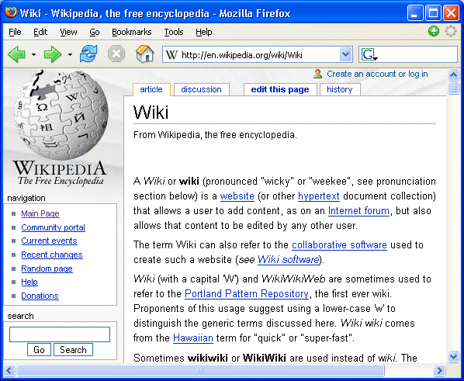
Wikipedia is a good example of a Wiki in which content is provided by contributors around the world.
The Wikipedia appears to have succeeded in providing an environment and culture which has minimised the dangers of misuse. Details of the approaches taken on the Wikipedia are given on the Wikimedia Web site [2].

Introduction To Wikis

A QA Focus Briefing Document

Background
Wiki technologies are increasingly being used to support development work across distributed teams. This document aims to give a brief description of Wikis and to summarise the main challenges to be faced when considering the deployment of Wiki technologies.

What Is A Wiki?
A Wiki or wiki (pronounced "wicky" or "weekee") is a Web site (or other hypertext document collection) that allows a user to add content. The term Wiki can also refer to the collaborative software used to create such a Web site [1].
The key characteristics of typical Wikis are the:
- Ability to create and edit content within a Web environment without the need to download any special software.
- Use of a simple markup language which is designed to simplify the process of creating and editing documents.
- Ability to easily create and edit content, often without need for special privileges.

Wikipedia – The Largest Wiki
The Wikipedia is the largest and best-known Wiki – see <http://www.wikipedia.org/>.
Wikipedia is a good example of a Wiki in which content is provided by contributors around the world.
The Wikipedia appears to have succeeded in providing an environment and culture which has minimised the dangers of misuse. Details of the approaches taken on the Wikipedia are given on the Wikimedia Web site [2].

What Can Wikis Be Used For?
Wikis can be used for a number of purposes:
- On public Web sites to enable end users to easily contribute information.
- In teaching. Wikis can provide an opportunity to learn about team working, trust, etc. A good example is provided by Queen’s University Belfast [3].
- By researchers. Wikis are by Web researchers to make it easier to develop collaborative documents e.g. the FOAF Wiki [4].
- On Intranets, where departmental administrators with minimal HTML experience may be able to manage departmental content.
- Wikis can be used at events for note-taking e.g. in discussion groups [5].

Wikis – The Pros And Cons
As described in [6] advantages of Wikis may include:
- No need to install HTML authoring tools; minimal training may be needed.
- Can help develop a culture of sharing and working together (cf. open source).
- Useful for joint working when there are agreed shared goals.
Disadvantages of Wikis may include:
- The success of the Wikipedia may not necessarily be replicated elsewhere.
- There is not (yet) a standard lightweight Wiki markup language.
- A collaborative Wiki may suffer from a lack of a strong vision or leadership.
- Can be ineffective when there is a lack of consensus.
- There may be copyright and other legal issues regarding collaborative content.
- It may be difficult for Wikis to gain momentum.

Further Information
- Wiki, Wikipedia, <http://en.wikipedia.org/wiki/Wiki>
- Wikimedia principles, Wikimedia, <http://meta.wikimedia.org/wiki/Wikimedia_principles>
- IT and Society Wiki, Queen’s University Belfast, <http://itsoc.mgt.qub.ac.uk/ITandSociety>
- FOAF Wiki, FoafProject, <http://rdfweb.org/topic/FoafProject>
- Experiences of Using a Wiki for Note-taking at a Workshop, Ariadne 42, Jan. 2005, <http://www.ariadne.ac.uk/issue42/web-focus/>
- Making the Case for a Wiki, Ariadne 42, Jan. 2005, <http://www.ariadne.ac.uk/issue42/tonkin/>

What Can Wikis Be Used For?
Wikis can be used for a number of purposes:
- On public Web sites to enable end users to easily contribute information.
- In teaching. Wikis can provide an opportunity to learn about team working, trust, etc. A good example is provided by Queen’s University Belfast [3].
- By researchers. Wikis are by Web researchers to make it easier to develop collaborative documents e.g. the FOAF Wiki [4].
- On Intranets, where departmental administrators with minimal HTML experience may be able to manage departmental content.
- Wikis can be used at events for note-taking e.g. in discussion groups [5].

Wikis – The Pros And Cons
As described in [6] advantages of Wikis may include:
- No need to install HTML authoring tools; minimal training may be needed.
- Can help develop a culture of sharing and working together (cf. open source).
- Useful for joint working when there are agreed shared goals.
Disadvantages of Wikis may include:
- The success of the Wikipedia may not necessarily be replicated elsewhere.
- There is not (yet) a standard lightweight Wiki markup language.
- A collaborative Wiki may suffer from a lack of a strong vision or leadership.
- Can be ineffective when there is a lack of consensus.
- There may be copyright and other legal issues regarding collaborative content.
- It may be difficult for Wikis to gain momentum.

Further Information
- Wiki, Wikipedia, <http://en.wikipedia.org/wiki/Wiki>
- Wikimedia principles, Wikimedia, <http://meta.wikimedia.org/wiki/Wikimedia_principles>
- IT and Society Wiki, Queen’s University Belfast, <http://itsoc.mgt.qub.ac.uk/ITandSociety>
- FOAF Wiki, FoafProject, <http://rdfweb.org/topic/FoafProject>
- Experiences of Using a Wiki for Note-taking at a Workshop, Ariadne 42, Jan. 2005, <http://www.ariadne.ac.uk/issue42/web-focus/>
- Making the Case for a Wiki, Ariadne 42, Jan. 2005, <http://www.ariadne.ac.uk/issue42/tonkin/>

