
An Introduction To
RSS And News Feeds

A QA Focus Document

Background
RSS is increasingly being used to provide news services and for syndication of content. The document provides a brief description of RSS news feed technologies which can be used as part of a communications strategy by projects and within institutions. The document summarises the main challenges to be faced when considering deployment of news feeds.

What Are News Feeds?
News feeds are an example of automated syndication. News feed technologies allow information to be automatically provided and updated on Web sites, emailed to users, etc. As the name implies news feeds are normally used to provide news; however the technology can be used to syndicate a wide range of information.

Standards For News Feeds
The BBC ticker [1] is an example of a news feed application. A major limitation with this approach is that the ticker can only be used with information provided by the BBC.
The RSS standard was developed as an open standard for news syndication, allowing applications to display news supplied by any RSS provider.
<title>BBC News</title>
<url>http://news.bbc.co.uk/
nol/shared/img/bbc_news_120x60.gif</url>
<link>http://news.bbc.co.uk/
</link>

<item>
<title>Legal challenge to ban on hunting</title>
<description>The Countryside Alliance prepares a legal challenge to Parliament Act ... </description>
<link>http://news.bbc.co.uk/
go/click/rss/0.91/public/-/1/hi/... </link>.
RSS is a lightweight XML application (see RSS fragment). Ironically the RSS standard proved so popular that it led to two different approaches to its standardisation. So RSS now stands for RDF Site Summary and Really Simple Syndication (in addition to the original phrase Rich Site Summary).
Despite this confusion, in practice many RSS viewers will display both versions of RSS (and the emerging new standard, Atom).

News Feeds Readers
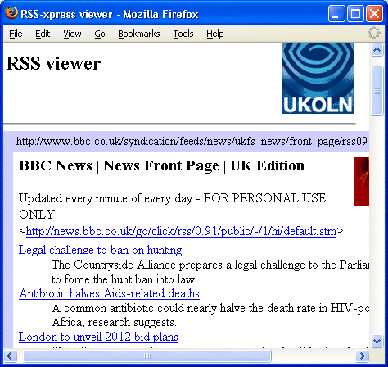
There are a large number of RSS reader software applications available [2] and several different models. RSSxpress [3] (illustrated right) is an example of a Web-based reader which embeds an RSS feed in a Web page. An example of a scrolling RSS ticker is shown above [4].
In addition to these two approaches, RSS readers are available with an email-style approach for the Opera Web browser [5] and Outlook [6] and as extensions for Web browsers [7] [8].

Creating News Feeds
There are several approaches to the creation of RSS news feeds. Software such as RSSxpress can also be used to create and edit RSS files. In addition there are a number of dedicated RSS authoring tools, including standalone applications and browser extensions (see [9]). However a better approach may be to generate RSS and HTML files using a CMS or to transform between RSS and HTML using languages such as XSLT.

Issues
Issues which need to be addressed when considering use of RSS include:
- The architecture for reading and creating RSS feeds
- The procedures needed in order to guarantee the quality of the news feed content
- How news feeds fits in with your organisation’s communications strategy

Further Information
- Desktop Ticker, BBC, <http://news.bbc.co.uk/1/hi/help/3223354.stm>
- RSS Readers, Weblogs Compendium, <http://www.lights.com/weblogs/rss.html>
- RSSxpress, UKOLN, <http://rssxpress.ukoln.ac.uk/>
- ENewsBar, <http://www.enewsbar.com/>
- RSS Newsfeeds In Opera Mail, <http://www.opera.com/products/desktop/m2/rss/>
- Read RSS In Outlook, intraVnews, <http://www.intravnews.com/>
- RSS Extension for Firefox, Sage, <http://sage.mozdev.org/>
- RSS Reader, Pluck, <http://www.pluck.com/product/rssreader.aspx>
- Web / Authoring / Languages / XML / RSS, Webreference.com, <http://www.webreference.com/authoring/languages/xml/rss/>

