

Using The
QA For Metadata Toolkit

A QA Focus Document

About The QA For Metadata Toolkit
The QA For Metadata Toolkit is an online resources which can be used as a checklist to ensure that your project or service has addressed key areas which can help to ensure that the metadata you use in your service is fit for its intended purpose and will ensure that your application will be interoperable.
.The QA For Metadata Toolkit is one of several toolkits which have been developed by the QA Focus project to support JISC’s digital library programmes.

Accessing The Toolkit
The QA For Metadata Toolkit is available from <http://www.ukoln.ac.uk/qa-focus/toolkit/>. The toolkit is illustrated in Figure 1:
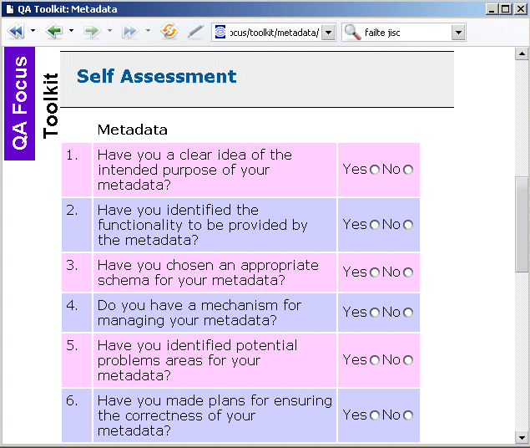
Figure 1: The QA For Metadata Toolkit

Using The
QA For Metadata Toolkit

A QA Focus Document

About The QA For Metadata Toolkit
The QA For Metadata Toolkit is an online resources which can be used as a checklist to ensure that your project or service has addressed key areas which can help to ensure that the metadata you use in your service is fit for its intended purpose and will ensure that your application will be interoperable.
.The QA For Metadata Toolkit is one of several toolkits which have been developed by the QA Focus project to support JISC’s digital library programmes.

Accessing The Toolkit
The QA For Metadata Toolkit is available from <http://www.ukoln.ac.uk/qa-focus/toolkit/>. The toolkit is illustrated in Figure 1:
Figure 1: The QA For Metadata Toolkit

Coverage
The toolkit addresses the following key areas:
- The purpose of your metadata
- The availability of cataloguing rules
- The technical architecture for creating and managing your metadata
- The approaches for checking the content of your metadata
- The approaches for checking the syntax of your metadata
- The interoperability of your metadata
- Training and development for staff involved in creating and managing your metadata
- The provision of documented policies
- The provision of systematic procedures which ensure that the policies are complied with.

Embedding The Toolkit In Your Project Activities
The toolkit can provide a simple checklist for ensuring that your project has addressed key areas in the development and deployment of metadata. As well as providing an aide memoire for projects the toolkit may also be useful in a more formal context. For example the answers could be used in initial scoping work at the early stages of a project or in reports to the project funders. In addition answers to the issues raised may be helpful for other potential users of the metadata or the final service provider of the project deliverables.

Further Information
Further toolkis are available at <http://www.ukoln.ac.uk/qa-focus/toolkit/>.

Coverage
The toolkit addresses the following key areas:
- The purpose of your metadata
- The availability of cataloguing rules
- The technical architecture for creating and managing your metadata
- The approaches for checking the content of your metadata
- The approaches for checking the syntax of your metadata
- The interoperability of your metadata
- Training and development for staff involved in creating and managing your metadata
- The provision of documented policies
- The provision of systematic procedures which ensure that the policies are complied with.

Embedding The Toolkit In Your Project Activities
The toolkit can provide a simple checklist for ensuring that your project has addressed key areas in the development and deployment of metadata. As well as providing an aide memoire for projects the toolkit may also be useful in a more formal context. For example the answers could be used in initial scoping work at the early stages of a project or in reports to the project funders. In addition answers to the issues raised may be helpful for other potential users of the metadata or the final service provider of the project deliverables.

Further Information
Further toolkis are available at <http://www.ukoln.ac.uk/qa-focus/toolkit/>.

