
Using The
QA For Web Toolkit


A QA Focus Document

About The QA Focus Toolkits
The QA Focus Toolkits are an online resource which can be used as a checklist to ensure that your project or service has addressed key areas which can help to ensure that your deliverables are fit for its intended purpose, widely accessible and interoperable and can be easily repurposed.
The QA For Web Toolkit is one of several toolkits which have been developed by the QA Focus project to support JISC’s digital library programmes. This toolkit addresses compliance with standards and best practices for Web resources.

Accessing The QA For Web Toolkit
The QA For Web Toolkit is available from <http://www.ukoln.ac.uk/qa-focus/toolkit/>. The toolkit is illustrated in Figure 1:
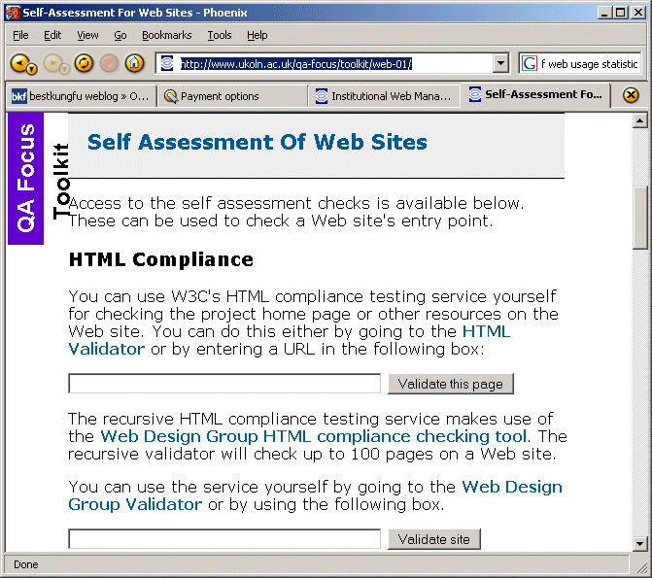
Figure 1: The QA For Web Toolkit

Coverage
The toolkit addresses the following key areas:
- HTML compliance of a page
- HTML compliance of a page and pages beneath it
- CSS compliance of a page
- Checking links on a page
- Checking links on a page and pages beneath it
- Checking HTTP for a page
- Dublin Core metadata which may be embedded within a HTML page

Embedding The Toolkit In Your Work
The toolkit can provide access to a set of online checking services.
You should seek to ensure that systematic checking is embedded within your work. If you simply make occasional use of such tools you may fail to spot significant errors. Ideally you will develop a systematic set of workflow procedures which will ensure that appropriate checks are carried out consistently.
You should also seek to ensure that you implement systematic checks in areas in which automated tools are not appropriate or available.
You may wish to use the results you have found for audit trails of compliance of resources on your Web site.

About The QA For Web Toolkit Resource
The QA For Web Toolkit described in this document provides a single interface to several online checking services hosted elsewhere. The QA Focus project and its host organisations (UKOLN and AHDS) have no control over the remote online checking services. We cannot guarantee that the remote services will continue to be available.

Further Information
Further toolkits are available at <http://www.ukoln.ac.uk/qa-focus/toolkit/>.

About QA Focus
The QA Focus advisory service is funded by the JISC to support JISC’s digital library programmes by assisting the implementation of Quality Assurance (QA) processes to ensure that project deliverables make use of appropriate standards and best practices in order to ensure interoperability and accessibility of the project deliverables.

