
How To Protect Your Rights With A Licence Agreement
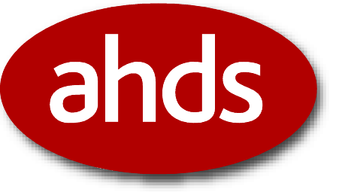

A QA Focus Document

Introduction
The Internet is often promoted as a means of getting information to the widest possible audience at the lowest possible cost. Barriers to the flow of information are not encouraged, and few repositories establish formal agreements with depositing authors.
Although mutual benefit is the primary goal of many collaborative projects, some method of formalizing the relationship between author and distributor is useful. A deposit agreement can be used to define a consensual contract between the depositing author and the repository, clarifying the rights and obligations of both.
The deposit agreement dictates several requirements of both parties:
- Defines how the repository will manage the content.
- Protection and ensure your rights
- Specifies what rights, if any, the repository gains over the content
- Indicates ownership of content and rights of the author if the repository closes.

Licensing Terms
The first aspect of a licence agreement that should be determined is the licensing terms. This indicates the distribution type permitted. Two types exist:
- Exclusive distribution – Exclusive licenses impose specific and wide-ranging restrictions upon distribution. They are primarily used for commercial repositories that are restricted by copyright or charges that non-exclusive distribution will devalue the content.
- Non-exclusive licenses – Non-exclusive licenses, typically found in academic-orientated repositories offer a useful alternative to commercial distribution that encourages the author to voluntarily submit work as a method of gaining wider public exposure. These non-exclusive licenses establish the rights of the depositor to submit work to differing repositories at a subsequent date without legal restrictions.

Requirements
To protect the organization from legal threats at a later date the licence agreement requires several issues to be considered during the submission lifetime. In the initial stages the repository should establish content ownership, audience and potential use, migration and distribution rights. In the long-term the repository should consider withdrawal criteria.

Initial Stages of Development
- Establish ownership: A licence agreement must first establish whom the owners are, and if it differs from the author. This may help to minimize the repository’s legal liability by formally establishing that the depositor holds the necessary copyright to deposit the material and is able to do so without infringement.
- Confirm ownership: The licence agreement should clearly indicate that the depositor retains ownership. This is a particularly important inclusion in a deposit agreement, designed to protect the repository from potential legal action taken as a result of the actions of the author. Equally, the deposit agreement can help establish that the author is not legally responsible for ensuring the accuracy of the information they have provided if, for example, it later becomes out-of-date.
- Audience and potential use: In some circumstances, particularly exclusive distribution, a licence agreement will need to establish terms permitted by the author relating to potential usage. This may be prompted by concerns that wide dissemination will damage the long-term value of the content. Institutional repositories may wish to clarify with depositors that deposited e-prints will only be used for non-commercial or academic uses.

Mid-term Considerations
- Migration Strategy: For repositories such as the AHDS a migration strategy will be particularly important. This enables the repository to migrate the content to a different file format if the original submitted format becomes obsolete.

Long-term Considerations
- Withdrawal criteria: The licence agreement should establish the situations under which the author may withdraw their work from the repository and whether the repository can continue to hold relevant metadata records after it is withdrawn.
Licence agreements should be considered an essential part of an e-print repository’s operation. They can resolve many of the potential problems that might arise. For the repository, it provides a formal framework that defines what the repository can and cannot do, making it easier to manage the e-print in the long-term while helping to reduce its legal liabilities.

Further Information
- Common Deposit Agreement Form, AHDS,
<http://ahds.ac.uk/depositform.htm>
- American Chemical Society. - Copyright Status, <http://pubs.acs.org/instruct/copyright.pdf>
- Copyright Assignment, Science Magazine, <http://www.sciencemag.org/feature/contribinfo/prep/copyright.pdf>
- Deposit Agreement, Tardis, University of Southampton, <http://tardis.eprints.org/discussion/e-Prints%20Soton%20-deposit%20agreeement.doc>

