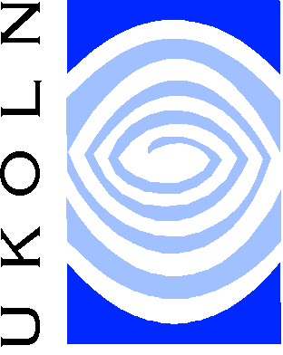
Protecting Copyright On
Your Own Work


A QA Focus Document

Introduction
The Internet contains an assortment of copyrighted work owned by millions of people or organisations throughout the world. The ease of publication and availability of text, graphics and video allow anyone to become their own publisher. As an effect, modern web sites contain a jigsaw of copyrighted works produced by multiple authors.
This free attitude to copyright presents a challenge to authors – what measures can be taken for authors to protect their own work? More accurately, can copyrighted work be protected in some way?
This document provides guidelines for protecting your own work. It describes methods of establishing authorship, possible licensing models that meet your needs, and methods of reflecting copyright on the Internet.

Choosing the Correct Licence
The Internet has forced an increasing debate on the role of IPR and copyright. This has resulted in alternatives to traditional intellectual property rights appearing.
To protect your work it is important that the distribution license is considered before you release your work. This can be achieved by answering several questions:
- Do I wish to allow others to improve my work without permission?
- Do I wish for others to distribute my work without permission?
- Do I wish for others to create derivative works without my permission?
If the answer to these questions is no, you are automatically assigned rights to copyright your work. However, if the answer is yes, you should seek alternative license agreements that preserve your right to place your work into the public domain or allow the user to perform certain actions. Popular variants include CopyLeft, notably the GPL, and Collective Commons – two different license agreements that avoid traditional copyright restrictions, by establishing permission to distribute content without restriction. More information can be found on these subjects in the QA Focus documents, ‘Choosing alternative licences’ and ‘How to protect your rights with a licence agreement’.

Managing Copyright on Own Work
Unless indicated, copyright is assigned to the author of an original work. When producing work it is essential that it be established who will own the resulting product – the individual or the institution. Objects produced at work or university may belong to the institution, depending upon the contract signed by the author. For example, the copyright for this document belongs to the AHDS, not the author. When approaching the subject, the author should consider several issues:
- Can I establish that I am the author of this work? At this point the author should provide evidence they produced the work on a specific date. One commonly used method is to post a sealed envelope to yourself or request that a solicitor store evidence within a safe. If ownership is challenged at a later date, the document can be opened in the presence of a solicitor.
- Am I using unaccredited copyrighted material produced by others? Published work that contains unaccredited material infringe upon the intellectual property of others. The results of such discovery will vary: the unaccredited author may request they are credited or a correction is published; the author may request their work is removed; or they make take legal action against the author. To avoid such issues, document all research made during investigation.
When producing work as an individual that is intended for later publication, the author should establish ownership rights to indicate how work can be used after initial publication:
- Ownership after publication Authors are encouraged to retain as many rights as possible to enable the continued use of articles in hard copy and electronic form.
- Ownership in different mediums In addition, where publication in a specific form (e.g. hard-copy) is the intention, rights to publish in other forms (e.g. electronic) should, if possible, be retained.

Indicating IPR through Metadata
If permission has been granted to reproduce copyright work, the institution is required by law to indicate intellectual property status. Metadata is commonly used for this purpose, storing and distributing IP data for online content. Several metadata bodies provide standardized schemas for copyright information. For example, IP information for a book could be stored in the following format.
<book id="bk112">
<author>Galos, Mike</author>
<title>Visual Studio 7: A Comprehensive Guide</title>
<publish_date>2001-04-16</publish_date>
<publisher>Addison Press</publisher>
<copyright>Galos, M. 2001</copyright>
</book>

Access inhibitors can also be set to identify copyright limitations and the methods necessary to overcome them: for example, limiting e-book use to IP addresses within a university environment.

Further Information
- PADI - Intellectual Property Rights Management,
<http://www.nla.gov.au/padi/topics/28.html>
- TASI - Looking after Copyright, IPR, Ethics and Data Protection, TASI,
<http://www.tasi.ac.uk/advice/managing/copyrights.html>

