Exploiting Networked Applications At Events


A QA Focus Document

About This Document
Increasingly WiFi networks are available in lecture theatres [1]. With greater ownership of laptops, PDAs, etc. we can expect conference delegates to make use of the networks. There is a danger that this could lead to possible misuse (e.g. accessing inappropriate resources; reading email instead of listening; etc.) This document describes ways in which a proactive approach can be taken in order to exploit enhance learning at events. The information in this document can also be applied to lectures aimed at students.

Design Of PowerPoint Slides
A simple technique when PowerPoint slides are used is to make the slides available on the Web and embed hypertext links in the slides (as illustrated). This allows delegates to follow links which may be of interest.
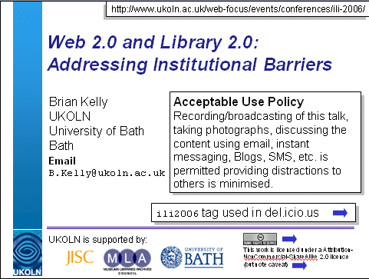
Providing access to PowerPoint slides can also enhance the accessibility of the slides (e.g. visually impaired delegates can zoom in on areas of interest).

Using Bookmarking Tools
Social bookmarking tools such as del.icio.us can be used to record details of resources mentioned [2] and new resources added and shared.

Realtime Discussion Facilities
Providing discussion facilities such as instant messaging tools (e.g. MSN Messenger, Jabber or Gabbly) can enable groups in the lecture theatre to discuss topics of interest.

Support For Remote Users
VoIP (Voice over IP) software (such as Skype) and related audio and video-conferencing tools can be used to allow remote speakers to participate in a conference [3] and also to allow delegates to listen to talks without being physically present.

Using Blogs And Wikis
Delegates can make use of Blogs to take notes: This is being increasingly used at conferences, especially those with a technical focus, such as IWMW 2006 [4]. Note that Blogs are normally used by individuals. In order to allow several Blogs related to the same event to be brought together it is advisable to make use of an agreed tag [5].
Unlike Blogs, Wikis are normally used in a collaborative way. They may therefore be suitable for use by small groups at a conference [6]. An example of this can be seen at the WWW 2006 conference [7].

Challenges
Although WiFi networks can provide benefits there are several challenges to be addressed in order to ensure that the technologies do not act as a barrier to learning.
User Needs: Although successful at technology-focussed events, the benefits may not apply more widely. There is a need to be appreciative of the event environment and culture. There may also be a need to provide training in use of the technologies.
AUP: An Acceptable Use Policy (AUP) should be provided.
Performance Issues, Security, etc. There is a need to estimate the bandwidth requirements, etc. in order to ensure that the technical infrastructure can support the demands of the event. There will also be a need to address security issues (e.g. use of firewalls; physical security of laptops, etc.).
Equal Opportunities: If not all delegates will possess a networked device, care should be taken to ensure that delegates without such access are not disenfranchised.

References
- Using Networked Technologies To Support Conferences, Kelly, B. et al, EUNIS 2005,
<http://www.ukoln.ac.uk/web-focus/papers/eunis-2005/paper-1/>
- Use Of Social Tagging Services At Events, QA Focus briefing document no. 105, <http://www.ukoln.ac.uk/qa-focus/documents/briefings/briefing-105/>
- Interacting With Users, Remote In Time And Space, Phipps, L. et al, SOLSTICE 2006, <http://www.ukoln.ac.uk/web-focus/events/conferences/solstice-2006/>
- Workshop Blogs, IWMW 2006,
<http://www.ukoln.ac.uk/web-focus/events/workshops/webmaster-2006/blogs/>
- Use Of Social Tagging Services At Events, QA Focus briefing document no. 105,
<http://www.ukoln.ac.uk/qa-focus/documents/briefings/briefing-105/>
- Guide To The Use Of Wikis At Events, QA Focus briefing document no. 104,
<http://www.ukoln.ac.uk/qa-focus/documents/briefings/briefing-104/>
- WWW2006 Social Wiki, WWW 2006, <http://www2006.org/wiki/w/Main_Page>

