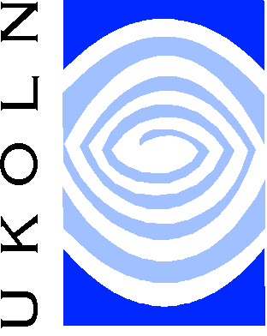
3 Sign-off QA
Sign-off QA is implementing an audited system to assure that all images and their associated metadata are created to the established quality standard. A QA audit history is made to record all actions undertaken on the image files.
- Every image must be visually checked and signed off with name and time recorded within audit history
- All metadata must be reviewed by operator and signed off with name and time
- Equipment must be calibrated and checked regularly
- All workflow procedures reviewed and updated as necessary

4 On-going QA
On-going QA is implementing a system to safeguard the value and reliability of the images into the future. However good the initial QA, it will be necessary to have a system that can report, check and fix any faults found within the images and associated metadata after the project has finished. This system should include:
- Fault report system that allows faults to be checked and then if possible fixed
- Provision for ongoing digital preservation (including migration of image data)
- Ownership and responsibility for images, metadata and IMS
- A reliable system for the on-going creation of surrogate images as required

QA in the Digitisation Workflow
Much of the final quality of a delivered image will be decided, long before, in the initial ‘Strategic’ and ‘Process’ QA stages where the digitisation methodology is planned and equipment sourced. However, once the process and infrastructure are in place it will be the operator who needs to manually evaluate each image within the ‘Sign-off’ QA stage. This evaluation will have a largely subjective nature and can only be as good as the operator doing it. The project team is the first and last line of defence against any drop in quality. All operators must be encouraged to take pride in their work and be aware of their responsibility for its quality.
It is however impossible for any operator to work at 100% accuracy for 100% of the time and faults are always present within a productive workflow. What is more important is that the system is able to accurately find the faults before it moves away from the operator. This will enable the operator to work at full speed without having to worry that they have made a mistake that might not be noticed.
The image digitisation workflow diagram shows one possible answer to this problem.

Image QA In The Digitisation Workflow

A QA Focus Document

Introduction
Producing an archive of high-quality images with a system containing associated delivery images is not easy. The workflow consists of many interwoven stages, each building on previous steps. If, at any stage, image quality is compromised within the workflow, it has been totally lost and can never be redeemed. It is therefore important that image quality is given paramount consideration at all stages of a project from initial project planning through to exit strategy.
Once the workflow is underway, quality can only be lost and the workflow must be designed to capture the required quality right from the start and then safeguard it.

Image QA
Image QA in a digitisation project’s workflow can be considered a 4-stage process:

1 Strategic QA
Strategic QA is undertaken in the initial planning stages of the project when the best methodology to create and support your images, now and into the future will be established. This will include:
- Choosing the correct file types and establishing required sizes
- Sourcing and benchmarking all equipment
- Establishing capture guidelines
- Selecting technical metadata

2 Process QA
Process QA is establishing quality control methods within the image production workflow that support the highest quality of capture and image processing, including:
- Establishing best ‘image capture’ and ‘image processing’ methodology and then standardising and documenting this best practice
- Regularly calibrating & servicing all image capture and processing equipment
- Training operators and encouraging a pride in quality of work
- Accurate capture of metadata
Produced by QA Focus - a JISC-funded advisory service supporting JISC 5/99 projects Oct 2002

