
404 Error Pages
On Web Sites


A QA Focus Document

Importance Of 404 Error Pages
A Web sites 404 error page can be one of the most widely accessed pages on a Web site. The 404 error page can also act as an important navigational tool, helping users to quickly find the resource they were looking for. It is therefore important that 404 error pages provide adequate navigational facilities. In addition, since the page is likely to be accessed by many users, it is desirable that the page has an attractive design which reflects the Web sites look-and-feel.

Types Of 404 Error Pages
Web servers will be configured with a default 404 error page. This default is typically very basic.
In the first example shown the 404 page provides no branding, no help information and no navigational aids. This is the drafult 404 error message for Web sites hosted on an Apache Web server.

An example of a richer 404 error page is illustrated. In this example the 404 page is branded with the Web site’s colour scheme, contains the Web site’s standard navigational facility and provide help information.
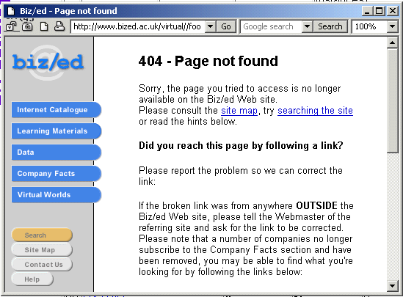

404 Error Pages
On Web Sites
A QA Focus Document

Importance Of 404 Error Pages
A Web sites 404 error page can be one of the most widely accessed pages on a Web site. The 404 error page can also act as an important navigational tool, helping users to quickly find the resource they were looking for. It is therefore important that 404 error pages provide adequate navigational facilities. In addition, since the page is likely to be accessed by many users, it is desirable that the page has an attractive design which reflects the Web sites look-and-feel.

Types Of 404 Error Pages
Web servers will be configured with a default 404 error page. This default is typically very basic.
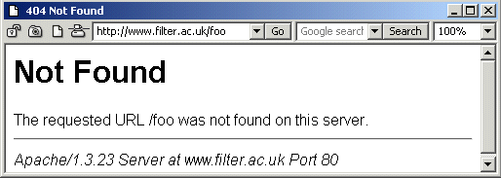
In the first example shown the 404 page provides no branding, no help information and no navigational aids. This is the drafult 404 error message for Web sites hosted on an Apache Web server.
An example of a richer 404 error page is illustrated. In this example the 404 page is branded with the Web site’s colour scheme, contains the Web site’s standard navigational facility and provide help information.

Functionality Of 404 Error Pages
It is possible to define a number of types of 404 error pages:

Server Default
The server default 404 message is very basic. It will not carry any branding or navigational features which are relevant to the Web site.

Simple Branding, Navigational Features Or Help Information
The simplest approach to configuring a 404 page is to add some simple branding (such as the name of the Web site) or basic navigation features (link to the home page) or help information (an email address).

Richer Branding, Navigational Features, Help Information Or Additional Features
Some 404 pages will make use of the Web sites visual identity (such as a logo) and will contain a navigational bar which provides access to several areas of the Web site In addition more complete help information may be provided as well as additional features such as a search facility.

Full Branding, Navigational Features, Help Information And Additional Features
A comprehensive 404 page will ensure that all aspects of branding, navigational features, help information and additional features such as a search facility are provided.

As Above Plus Enhanced Functionality
It is possible to provide enhanced functionality for 404 pages such as context sensitive help information or navigational facilities, feedback mechanisms to the page author, etc.

Further Information
An article on 404 error pages, based on a survey of 404 pages in UK Universities is available at <http://www.ariadne.ac.uk/issue20/404/>. An update is available at <http://www.ariadne.ac.uk/issue32/web-watch/>.

Functionality Of 404 Error Pages
It is possible to define a number of types of 404 error pages:

Server Default
The server default 404 message is very basic. It will not carry any branding or navigational features which are relevant to the Web site.

Simple Branding, Navigational Features Or Help Information
The simplest approach to configuring a 404 page is to add some simple branding (such as the name of the Web site) or basic navigation features (link to the home page) or help information (an email address).

Richer Branding, Navigational Features, Help Information Or Additional Features
Some 404 pages will make use of the Web sites visual identity (such as a logo) and will contain a navigational bar which provides access to several areas of the Web site. In addition more complete help information may be provided as well as additional features such as a search facility.

Full Branding, Navigational Features, Help Information And Additional Features
A comprehensive 404 page will ensure that all aspects of branding, navigational features, help information and additional features such as a search facility are provided.

As Above Plus Enhanced Functionality
It is possible to provide enhanced functionality for 404 pages such as context sensitive help information or navigational facilities, feedback mechanisms to the page author, etc.

Further Information
An article on 404 error pages, based on a survey of 404 pages in UK Universities is available at <http://www.ariadne.ac.uk/issue20/404/>. An update is available at <http://www.ariadne.ac.uk/issue32/web-watch/>.

