
Use Of Proprietary Formats
On Web Sites


A QA Focus Document

Use Of Proprietary Formats
Although it is desirable to make use of open standards such as XHTML when providing access to resources on Web sites there may be occasions when it is felt necessary to use proprietary formats. For example:
- It is necessary to provide control over the page appearance which can only be achieved easily using formats such as MS Word, Adobe PDF, etc.
- Open standards are not yet available or tools are not yet widely deployed.
- Web access is used as a mechanism for delivering files.
- Conversion to an open format would be resource-intensive.
- The resource was created by a third-party and you do not have access to tools to convert the resource.

URL Naming Conventions For Access To Proprietary Formats
If it is necessary to provide access to a proprietary file format you should not cite the URL of the proprietary file format directly. Instead you should give the URL of a native Web resource, typically a HTML page. The HTML page can provide additional information about the proprietary format, such as the format type, version details, file size, etc. If the resource is made available in an open format at a later date the HTML page can be updated to provide access to the open format – this would not be possible if the URL of the proprietary file was used.
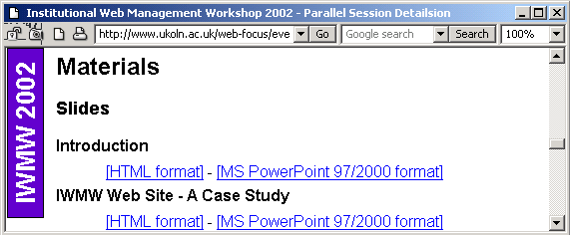
An example of this approach is illustrated. In this case access to MS PowerPoint slides are available from a HTML page. The link to the file contains information on the PowerPoint version details.
Note that HTML resources which are generated in this way should be stored in their own directory so that they can be managed separately from other resources.

Converting Proprietary Formats
Various tools may be available to convert resources from a proprietary format to HTML. Many authoring tools nowadays will enable resources to be exported to HTML format. However the HTML may not comply with HTML standards or use CSS and it may not be possible to control the look-and-feel of the generated resource.
Another approach is to use a specialist conversion tool which may provide greater control over the appearance of the output, ensure compliance with HTML standards, make use of CSS, etc.
If you use a tool to convert a resource to HTML it is advisable to store the generated resource in its own directory in order to be able to manage the master resource and its surrogate separately.
You should also note that some conversion tools can be used dynamically, allowing a proprietary format to be converted to HTML on-the-fly.

MS Word
MS Word files can be saved as HTML from within MS Word itself. However the HTML that is created is of poor quality, often including proprietary or deprecated HTML elements and using CSS in a form which is difficult to reuse.

MS PowerPoint
MS PowerPoint files can be saved as HTML from within MS PowerPoint itself. However the Save As option provides little control over the output. The recommended approach is to use the Save As Web Page option and then to chose the Publish button. You should then ensure that the HTML can be read by all browsers (and not just IE 4.0 or later). You should also ensure that the file has a meaningful title and the output is stored in its own directory.

Dynamic Conversion
In some circumstances it may be possible to provide a link to an online conversion service. Use of Adobe’s online conversion service for converting files from PDF is illustrated.
It should be noted that this approach may result in a loss of quality from the original resource and is dependent on the availability of the remote service. However in certain circumstances it may be useful.

About QA Focus
The QA Focus advisory service is funded by the JISC to support JISC’s digital library programmes by assisting the implementation of Quality Assurance (QA) processes to ensure that project deliverables make use of appropriate standards and best practices in order to ensure interoperability and accessibility of the project deliverables.

