JISC DEVELOPMENT PROGRAMMES
eBank UK Final Report

Project Acronym | eBank UK | Project ID
Project Title | eBank UK
Start Date | 1st September 2003 | End Date | 31st August 2004
Lead Institution | UKOLN, University of Bath
Project Director | Liz Lyon, UKOLN, University of Bath
Project Manager & contact details | Rachel Heery, UKOLN, University of Bath  01225 386724 r.heery@ukoln.ac.uk
Partner Institutions
  Department of Electronics & Computer Science
  University of Southampton
  Southampton
  SO17 1BJ
  Dr Leslie Carr
  Tel: 023 8059 4479
  Fax: 023 8059 2865
  Email: lac@ecs.soton.ac.uk
  PSIgate
  John Rylands University Library of Manchester
  Oxford Road
  Manchester
  M13 9PP
  John Blunden-Ellis
  Tel: 0161 275 8729
  Email: j.blunden-ellis@man.ac.uk
Project Web URL | www.ukoln.ac.uk/projects/ebank-uk/
Programme Name (and number) | Semantic Grid and Autonomic Computing Programme
Programme Manager | Nicole Harris

Document
Document Title | Final Report
Reporting Period | 1st September 2003 – 31st August 2004
Author(s) & project role | Monica Duke, Michael Day, Rachel Heery, Liz Lyon, Simon Coles
Date | 12 March 2005 | Filename | eBank-fin-rep-20050312
URL
Access | ✓ Project and JISC internal |  | □ General dissemination

Document History
Version | Date | Comments
0.1 | 20050312 | Submittted to JISC programme manager
0.2 | 20050520 | Typographical corrections

Table of Contents

Executive Summary 3
Background 4
Aims and Objectives 7
Methodology 7
Implementation 11
Outputs and Results 12
Outcomes 17
Conclusions 18
Implications 19
References 19
Appendixes 20

Acknowledgements
The eBank UK project is funded by the JISC under the Semantic Grid and Autonomic Computing Programme.

The Project Partners are UKOLN, University of Bath; Intelligence, Agents, Multimedia Group, School of Electronics and Computer Science, University of Southampton; School of Chemistry, University of Southampton; PSIgate, University of Manchester.

EBank UK acknowledges the participation of the National Crystallography Centre, University of Southampton by contributing the data and thanks the International Union of Crystallographers (IUCr) for permission to re-use their journal metadata in the demonstrator.

The contributions made by the participants in the eBank UK workshop are acknowledged.

Executive Summary

The first phase of the eBank UK Project has been successful in demonstrating proof-of-concept in the linking of research data generated in the discrete area of combinatorial chemistry to derived ePrints and scientific papers.

The scholarly knowledge cycle has been presented as the over-arching context in which eBank UK is positioned, as part of the changing landscape of scholarly communications.

The project partners, with staff coming from the three backgrounds of computer science, chemistry and digital library research, have worked effectively together, whilst acknowledging differences of approach and vocabulary. This has led to interesting and lively discussion and has highlighted some of the challenges which are faced by the hybrid eResearch community.

A data model and metadata schema has been developed upon which the demonstrators are based.

A repository demonstrator based on the EPrints.org software which contains datasets from crystallography experiments has been developed at Southampton.

The eBank Aggregator Service demonstrator based on the ePrints UK architecture which harvests metadata about datasets and scientific papers from third party providers, has been developed at UKOLN.

The Aggregator Service has been embedded within the Resource Discovery Network PSIgate portal as one potential link and access point for learners.

A number of project documents have been produced including a Technical Description of the Aggregator Service and eBank UK project scenarios and user requirements.

A Supporting Study have been written:

- Feasibility Report on Data Set Description and Schema

The eBank concept has been demonstrated to a sample of stakeholders at an Evaluation Workshop and their views have been recorded and a number of issues raised both for the project and for the funders.

Strong support for the eBank concept has been given by the International Union of Crystallographers and collaborative activity is underway to pursue closer links between the project and the professional association.

International awareness of the implications of linking data and the scholarly knowledge cycle concept has been achieved through a number of presentations and publications to the wider community.

All project outcomes and materials have been made available through the project web site.

Following successful progress during Phase 1, a programme of follow-on development activity to extend and build on the results has been conceived and funding secured. Phase 2 will focus on links to learning materials and pedagogical evaluation, together with consideration of service expansion and feasibility of application in related disciplinary areas.

Phase 2 is scheduled to begin in February 2005.

Background

Overview of the Scholarly Knowledge Landscape

The background and context for the eBank UK project is the changing landscape of scholarly communication afforded by the developing global network infrastructure (Internet, World Wide Web, Semantic Web and Grid) together with the potential for increasing links between the activities of e-research / e-science, digital libraries and e-learning at all levels from schools to post-doctoral study. The flow of data and information in the process of research and learning in an academic setting leads ultimately to the creation and acquisition of knowledge. Data and information is continuously used and re-used in new ways as part of a research activity or in the development of course materials in support of learning. These workflows are interlinked and together underpin the scholarly knowledge cycle [1] (Figure 1).

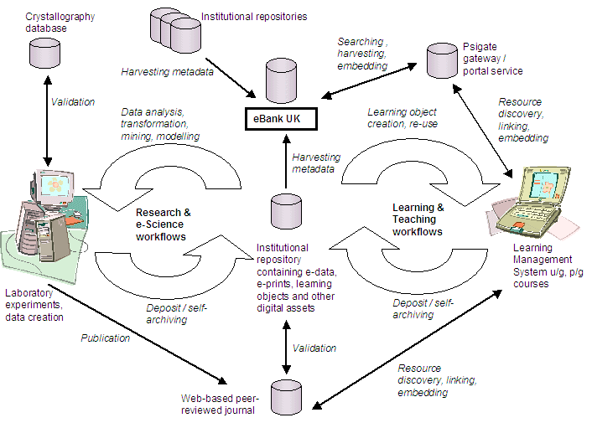
Figure 1: The Scholarly Knowledge Cycle

The creation, management, sharing and interoperation of scientific data (which may be, for example, numerical data generated by experiment or survey, images captured by earth observation platforms or as part of a clinical studies, together with any associated metadata) is an intrinsic part of e-science, keeping data and metadata together. This process consists of one or more sub-processes which might include aggregation of experimental data, selection of a particular data subset, repetition of a laboratory experiment, statistical analysis or modelling of a set of data, manipulation of a molecular structure, annotation of a diagram or editing of a digital image, and which in turn generate modified datasets. This in turn entails managing version control and access to previous versions, as well as auditing information on processes and transformations.

The successive levels of derived data are closely related to the original data (through refinement, transformation, interpretation, generalisation, etc.) and may themselves be further processed to form successive interpretations or abstractions. If the data at any particular stage of processing is considered to be generically useful, it may be considered for inclusion in a publicly-available database for use beyond the boundaries of the project which funded the data. This has only been undertaken in fairly specialised fields of joint community endeavour (for example in the bioinformatics field, protein and genome sequences databases, and in chemistry, material safety information, and the crystal structures in the Cambridge Structural Database [2]), as such databases require some level of service guarantee from a service provider.

Provision in other chemistry areas i.e. on spectroscopic data is patchy due to the cost of maintaining the data as well as attitudes towards sharing. Eventually, useful and interesting knowledge can be interpreted from the processed data; this knowledge is interpolated into a scientific paper or article for communication with the scientific community through the publication process. Sufficient data must be included to support the arguments and claims advanced in the article, however the practical limits of the publication medium mean that the data is shown in a very restricted form (such as a graph or summary table). As well as submitting the paper for peer review and publication, it may be deposited in an e-print archive for immediate dissemination and discussion by the community.

These secondary items (the articles and database tables) can themselves re-enter the research cycle through a citation in a related paper or inclusion in a meta-study, or inclusion in postgraduate training or undergraduate learning activities by a reference in a reading list or in modular materials as part of an online course in a Learning Management System.

Addressing the Publication Bottleneck: Integrating Data Dissemination into the Workflow

There is increasing interest in establishing institutional repositories to provide services to manage the variety of digital materials that form the intellectual output of educational and research institutions [3]. Significantly such institutional repositories also have a central role in taking forward the open access agenda, supporting e-print archives that enable self-archiving of journal article pre-prints and post-prints, and potentially other categories of material, by academic staff [4]. This changing landscape offers opportunities to curate scientific datasets more effectively, improving access and integration between services.

Currently, once a research experiment is finished the initial dissemination may be via a letter or communication, followed later by a more detailed explanation in a full paper. The eBank UK project was conceived to demonstrate how data might be ‘published at source’ directly in open archives and subsequently linked to either peer- reviewed journal articles or automatically deposited entries in specialised databases.

The key issue is that the accepted unit of dissemination is the peer-reviewed journal article; currently the relationship between the article and the collection of data that underpins it (as made available in the published article itself) is weak, being expressed in reduced graphical or tabular form. Consequently not only is a small minority of scientific research being published in recognised outlets, but the amount of useful information being disseminated by those articles is a tiny fraction of the available (original) information. In addition, publication in the mainstream literature still offers only indirect (and often expensive) access to this data. As a consequence the user community is deprived of valuable information and funding bodies are getting a poor return for their investments. By moving towards a ‘publication at source’ approach access and discovery of research data would be made easier, which in turn would encourage re-use of data in further experiments. The benefits of the sharing of primary data were also acknowledged in the House of Commons Science and Technology Committee Report “Scientific Publications: Free for All?” (July 2004) and in the Government Response (November 2004).

In parallel to increasing interest in archiving data, there is growing policy support and funding to encourage researchers to self-archive peer-reviewed journal articles in institutional repositories. This offers an opportunity to integrate services offered by eData archives and journal article e-print archives. As the availability of journal article e-prints increases, users would benefit from a service linking back from the article to the raw or processed data. Various services might be built based on metadata made available through institutional repositories: providing context sensitive linking within electronic versions of journal, links from e-print archives to datasets, linking to datasets from e-learning portals.

The eBank UK project is addressing this challenge of whole-lifecycle reuse by investigating the role of aggregator services in linking data-sets from Grid-enabled projects to e-prints contained in digital repositories through to peer-reviewed articles as resources in e-learning portals. The eBank UK demonstrator shows how an e-prints repository of peer-reviewed journal articles could include links to associated research data. In particular eBank UK focuses on the potential role for aggregator services that might harvest metadata describing datasets from institutional repositories as contributed by Grid-enabled projects. The project chose the Open Archives Initiative Protocol for Metadata Harvesting (OAI-PMH) [5] to provide the technical infrastructure for this.

Building on Existing Infrastructure and the Open Access Culture

For historical reasons, the OAI-PMH is very closely tied with the Open Access philosophy of publication, whereby the dissemination of publications (such as journal articles) is improved by depositing the item in an institutional or subject-based repository. The repository acts as a central focus from which the article, together with the associated metadata, may be shared freely with the research community. The very first Open Access collections (e.g., arXiv [6], CogPrints [7]) provided the test-bed on which the OAI-PMH was developed and refined, until it evolved into the current stable version. Partly as a consequence of this association, OAI-PMH-compliant repositories have proliferated, and a number of Open Access collections fulfilling the role of data providers (in an OAI-PMH sense) are currently available. These data providers are distributed in the US, Europe, Australia and wider. They take on a different focus according to their context; many are institutional and are seen as a central point of dissemination for an institution’s published assets; however different flavours of repositories are possible, for example centred on images, theses and even CVs.

In the OAI-PMH model, service providers fulfil a harvesting role, i.e. resource descriptions from one or more data providers are sent to the service provider in response to requests. The service provider is then positioned to provide a single point of entry to disparate repositories of resources descriptions, and can offer a variety of services to support the discovery of published data and literate. Compared to the number of data providers, the emergence of service providers has been slower. Arguably this is an unavoidable situation. A necessary level of data provider availability is required to provide the material to fulfil service provider requests. A range of data provider instances would also be needed to motivate the development of different service provider models. A lag-time may be inevitable and service provider maturity may follow on the success of the data provider take-up.

The ePrints UK project [8] is one example of a service provider. Funded by JISC, ePrints UK is providing a focus for the cross-searching of assets made available by institutions, presenting a subject-based service targeting the existing user base of JISC-funded subject-based resource discovery services. Furthermore, e-prints UK is seeking to enhance the harvested metadata through citation analysis, name authority services and automated subject classification.

In the eBank UK project, this Open Access philosophy is being extended to research data. A data repository has been created at the University of Southampton. Crystallographers deposit the datasets produced at the National Crystallography Service in an enhanced version of the EPrints.org software [9] that accommodates self-archiving by chemists. During the deposit process, metadata about the datasets is entered or generated automatically. This metadata is then made available in the repository that, in addition to supporting local searching, browsing and downloading of datasets, also acts as an OAI-PMH compliant data provider. eBank UK has also implemented an example of a service provider that harvests metadata about datasets from the repository (using OAI-PMH). This metadata provides the basis on which to create innovative services that support the discovery and re-use of datasets, as well as creating links with the published literature. The shared infrastructure re-using the OAI-PMH supports interoperability between systems disseminating publications and those disseminating research datasets.

In summary, the eBank UK project builds on recent developments in the area of open access publishing and dissemination. It is contributing to advancing knowledge in the areas of data provider and service provider, in the context of the OAI-PMH, by extending use of the protocol to the dissemination and discovery of scientific datasets. An innovative repository has been created which is specialised in the area of crystallography. A service provider has been demonstrated showing the potential for aggregating services to build added-value services. Two reports, one on provenance, and one on dataset descriptions and schema, crystallise the knowledge gained in these two areas during the project. Finally, the feasibility of applying the eBank UK approach in other disciplines needs to be assessed and the process has begun by initiating discussion in a workshop with a number of stakeholders.

The longer-term benefits that are expected to accrue from this approach are:

- Creation of an Institutional Repository of Scientific Data – ‘publication at source’
- Improved access to scientific data and timely dissemination of data results
- Streamlined access to data files through a common interface
- Enabling re-use of data by other scientists
- New ways to assess and validate scientific results
- Curation of data built into scientist’s workflow
- Requirements for next-generation open-access tools are better understood
- Promotion of cross-disciplinary collaboration by exchanging data with wider communities

Aims and Objectives

The overall aim of the project is to demonstrate how a repository of e-prints and peer-reviewed articles might link to associated metadata describing research data. This demonstrator will be designed to test the hypothesis that research and learning processes are cyclical in nature, and that subsequent outputs which contribute to knowledge, are based on the continuous use and re-use of data and information.

The specific objectives are to:

- Identify the wider issues and requirements of stakeholders relating to the discovery, access, use and re-use of research data, Grid datasets and derived information contained in digital libraries and virtual learning environments
- Produce a version of the EPrints.org software that will accommodate self-archiving of research data, and enable this research data to be linked to subsequent articles and other derived information
- Develop and test a demonstrator interface based on the ePrints UK service, hosted on the RDN Web site
- Develop and test a demonstrator interface based on the PSIgate portal/gateway
- Populate the eBank repository with sample metadata relating to research data-sets and publications
- Publish two supporting studies 1) on provenance which will contain a review of current research, issues and challenges; 2) on dataset descriptions and schema which will contain a feasibility report on metadata schema relating to datasets and will focus on the chemistry domain
- Evaluate the project outcomes through a consultative workshop for the wider community and make recommendations to the JISC for future work

Methodology

Overall Approach

The project activities are a mix of technical development work, desk-based research and evaluation / consultation with the community. The project represents an opportunity to bring together the digital library community with the Grid / computer science community in a very practical way and the approach reflects the strong partnership between these groups.

The project deliverables include a pilot service to be tested and evaluated by the user community. Within the context of the JISC Information Environment architecture, eBank UK acts as an aggregation / fusion service, conforming to JISC IE recommended standards and protocols.

The two supporting studies deliver documentary reports that will inform both the funding body and the wider community. The views of stakeholders will be pro-actively gathered and represented at the consultation workshop and the project will take account of identified requirements in technical development process.

The eBank UK demonstrator is being developed within a particular chemistry domain, crystallography, with a view to assessing, in the longer term, the feasibility of a generic approach across other disciplines.

Choosing an exemplar area

The EPSRC National Crystallography Service (NCS) is housed in the School of Chemistry at the University of Southampton, and is an ideal case study due to its high sample throughput, state of the art instrumentation, expert personnel and profile in the academic chemistry community. Moreover, recent advances in crystallographic technology and computational resources have caused an explosion of crystallographic data, as shown by the recent exponential growth of the Cambridge Structural Database (CSD). However, despite this rise it is commonly recognised that, via traditional publication routes, approximately only 20% of the data generated globally is reaching the public domain. This situation is even worse in the high throughput NCS scenario where approximately 15% of its output is disseminated, despite producing more than 60 peer reviewed journal articles per annum. With the advent of the e-Science environment imminent, this problem can only get more severe.

eBank UK has chosen to focus on crystallography as this area of research has a strict workflow and
produces data that is rigidly formatted to an internationally accepted standard, namely the Crystallographic Information File (CIF) standard [10, 11], maintained by the International Union of Crystallography [12].

To improve dissemination of published articles, the Open Access Initiative allows researchers to share metadata describing papers that they make available in ‘institutional’ or ‘subject-based’ repositories. Building on the OAI concept, eBank UK created an institutional repository that also makes available all the raw and processed data from crystallography experiments.

Architectural overview

The architecture of eBank UK adopts the Open Archives Initiative Protocol for Metadata Harvesting (OAI-PMH) [5], which offers a specific design approach. OAI-PMH envisages a class of ‘data providers’ acting as repositories of resources. These data providers are accessed programmatically by means of a number of requests (which together make up the OAI-PMH). A second class of ‘service providers’ issues the OAI-PMH requests to the data providers. A series of requests made by the service provider (the full details of which are beyond the scope of this report) culminates in ‘harvesting’ of the metadata about the resources held by the data provider. In other words, resource descriptions held by the data provider are sent in response to the service provider requests. By selectively making requests to one or more data providers, the service provider aggregates a collection of resource descriptions. The service provider (or aggregator) is thus positioned to provide a single point of entry to disparate repositories of resources and resource descriptions, and can offer a variety of services to support the discovery of published data and literature.

The metadata about the datasets available in the repository are harvested by a central service using the OAI-PMH. This metadata is then indexed together with any other available metadata about research publications. A searchable interface enables users to discover datasets as well as related literature. The metadata contains links back to the datasets which the user will be able to follow in order to obtain access to the original data, when this is available. Harvested metadata from different repositories not only provides a common entry point to potentially disparate resources (such as datasets in dataset repositories and published literature which may reside elsewhere) but also offers the potential of enhancement of the metadata such as the addition of subject keywords to research datasets based on the knowledge of subject classification terms assigned to related publications. A further area of work investigates the embedding of the search interface within web sites, adopting their look-and-feel. The PSIgate portal [13] will be used to pilot these embedding techniques based on CGI-mechanisms and portal-related standards, particularly suitable for resource discovery in a teaching and research training context.

Methodology in more detail – Building of the eCrystals Repository at the University of Southampton

Publishers of crystal structures, and indeed most types of scientific data, make available to subscribers limited amounts of results data, such as CIFs. However this is only offering a partial solution, as the final result in most cases is merely a fraction of the digital data generated during the course of the experiment. Moreover this single result does not allow the 'reader' to assess the interpretations and assumptions made by the experimenter during the data workup. This is due to traditional publishing protocols being time consuming and considerably delaying, incapable of keeping up with the current data explosion. In addition such services are selective, and do not make available all the metadata that is associated with the primary data.

A schema for the crystallographic experiment has been devised that details crystallographic metadata items and is built on a generic schema for generic scientific experiments. A modified version of the eprints.org software which takes this schema into account has been used to support the deposition of data from crystallographic experiments carried out at the NCS.

The deposition process generates metadata to be presented to the OAI interface by two different mechanisms. Firstly the depositor must enter metadata manually, which is mainly common bibliographic information but also includes chemical information items that have been added to the conventional Dublin Core schema. The chemical information includes, for example, an INChI code [14], which is an international identifier that uniquely describes the two dimensional structure.

During the deposition of data in a Crystallographic e-print metadata items are seamlessly extracted and indexed for searching at the local archive level. The top-level document includes 'Dublin Core bibliographic' and 'chemical identifier' metadata elements in an OAI-PMH) compliant form, which allow access to a secondary level of searchable crystallographic metadata items, which are in turn directly linked to the associated archived data. In this manner the output from a crystallographic experiment may be disseminated as ‘data’ in such a way that aggregator services and researchers may add value to it.

Methodology in more detail – Aggregator services

As explained in the preceding section, datasets are created during experimental processes and are instantiated as a number of data files. The files are self-archived in an OAI-PMH repository and descriptive metadata is created as part of the deposit process. The metadata consists of a number of fields that are either entered either by the depositor or generated automatically by the modified EPrints.org software. In the institutional eData repository, a local web interface (using HTML) is presented to the user. An OAI-PMH interface is also available for machine to machine interaction by OAI-PMH compliant service providers.

The eBank UK aggregator harvests the metadata from this data repository by making OAI-PMH requests. A metadata schema used for exchange was defined using XML Schemas. An SGML indexing and searching engine, Cheshire [15], is then used to provide indexing and searching functionality over the metadata. The Cheshire search engine used in the eBank UK service provider makes it simple to make the data available through additional machine interfaces, such as the SOAP-based Search/Retrieve Web Service (SRW) [16]. This provides a basis for embedding the search service into external frameworks, such as portals; other mechanisms that could be employed include simple CGI-based mechanisms and portal protocols such as WSRP.

When combined with publication metadata, any links made between different datasets, or datasets and publication can be revealed to the user in the display of the search results. Links can be made indirectly, for example by identifying common occurrences of author names, keywords or other subject-specific terms (such as chemical identifiers in our particular crystallography exemplar). Alternatively, direct links can be created if there is a specific reference, in the dataset or the publication metadata, to the related work. For example, an OpenURL [17] could be generated to link to an instance of a journal article that is available electronically in a user’s institution, if sufficient metadata about this related article is included in the metadata record describing the data set.

Methodology in more detail – Embedding in PSIgate

One further area of work in the eBank UK project is the embedding of the search service into external services to reach the user base by means of alternative points of entry. There are a number of mechanisms by which this can be achieved. All the mechanisms would allow a third party service to make requests to the service provider, which in turn returns results in a manner that can be manipulated by the third party to fit the look and feel of their interface, for example the University portal or a subject portal. EBank UK has implementation experience of using CGI mechanisms, web service protocols (SRW) and portal technologies. These techniques will be used to present the search service through PSIgate, which has an audience in higher and further education, mainly in the UK, but also worldwide, with an interest in the physical science. The eBank UK search service will complement the other features of PSIgate, adding discovery and access of research data to the landscape of scientific services already on offer at PSIgate.

Methodology in more detail – Evaluation (Workshop)

Towards the end of the first year of funding, in August 2004, a workshop was held by invitation. A number of representatives from various communities (scientists, funding bodies, publishers) attended and contributed to evaluating the progress of the eBank UK project. The demonstrators were presented to the participants and lessons learnt and other issues were discussed. The number of participants was kept small and select so that there would be sufficient time for all views to be expressed and to optimise communication in order to obtain representative feedback. This also gave an opportunity to the participants to network and make contacts with others with similar interests. A workshop web page was created to allow participants to familiarise themselves with the objectives of the project and the aims of the meeting. Invitations were sent by email and invitees were welcomed to present a short overview of the issues from their perspective during the workshop.

Standards and Interoperability

The services that can be built on aggregated metadata can only be as good as the metadata that is available to them. To achieve interoperability between dataset and publication metadata, there must exist some consensus on the data models and the metadata schemas being used to exchange metadata. Furthermore, to support discovery facilities between datasets from different communities, there must be some agreed commonality in the models and schemas if cross-disciplinary services are to be built.

As a starting point the eBank UK project has taken the Dublin Core metadata element set [18], and other DC terms available [19], and adapted them to describe the datasets that are deposited by crystallographers in the institutional eData repository. The reasons for this are two-fold. Firstly, simple DC is mandated within the OAI-PMH (although the protocol also encourages the exposure of specialized metadata records alongside the minimally required DC). Secondly, DC was conceived to provide a minimum baseline of interoperability, which can be extended and specialized for specific needs.

The metadata schema uses elements from the fifteen elements of the Dublin Core Element Set as the basis for descriptions. For example the creators of the datasets are designated within the Dublin Core creator element. Discussion with the users revealed that there are a number of different ways to describe the subject of the datasets. Crystallography experiments revolve around a single molecule, which can be thought of as the ‘topic’ of the experiments. There are a number of established ways of identifying molecules, which include internationally recognised methods of specifying their formulas or names. These different vocabularies have been incorporated into the schema through the encoding schemes facility of qualified Dublin Core. The Dublin Core Metadata Initiative (DCMI) provides recommendations for including terms from vocabularies in encoded XML suggesting “Encoding schemes should be implemented using the 'xsi:type' attribute of the XML element for the property.” An example from the eBank UK metadata records for datasets is the representation of the chemical empirical formula as:

<dc:subject xsi:type="eBankUKterms:EmpiricalFormula">C288 H200 Cl24 F48 O48 P16 Pd16</dc:subject>

Efforts are ongoing in the chemistry community to agree on namespaces for these vocabularies [16]. As these namespaces emerge, they can substitute the eBank UK namespace designations, which have been used temporarily until the standard recommendations become available.

Experience within the e-prints community has shown that there are significant challenges to be met when building services on aggregated metadata [20]. Although a simple set of metadata elements like the Dublin Core goes some way to providing interoperability, guidelines are required to help reach some consensus on the specific interpretation of the use of those elements, for example by specifying an acceptable minimum of metadata to be completed, agreeing on the format for author names and encoding the identifiers of the resources described [21].

In principle, the Dublin Core fields used for ‘bibliographic’ information in the data set descriptions should work well with descriptions of published literature available through the OAI-PMH and which could be harvested and cross-searched in the eBank UK service. In practice the Open Access approach is not currently as widespread in the Chemistry community as in some other fields, and metadata available via the OAI-PMH that describes the published literature is rather scarce. However, some publishers have recently become more willing to expose bibliographic information on articles in journals that they publish more openly i.e. through specified open standards (if not the articles themselves). The eBank UK project has been pro-active in engaging the leading organisations involved in the quality control, publication and dissemination of crystallography data. Through the crystallography partners, contact was made with a major publisher in the area and a sample of metadata from their publications was sought.

With regards to information retrieval standards, eBank UK has adopted the protocols recommended in the JISC IE: OAI-PMH for metadata harvesting and Z39.50 for search and retrieve. Both these protocols are ones which UKOLN has experience with; open source tools are easily available and previous experience with the software gave confidence in its support for the standards chosen, ease of use, and responsive support from the software developers should any problems arise.

Implementation

The eBank UK project was focused on the development of linked services that could be used for the publication, aggregation and re-use of scientific data. At the start of the project, several meetings were held to discuss the project plan and the details of the proposed demonstrator service. From these initial discussions it became clear that crystallography would be a good exemplar for the project. For example, while there was an existing tradition of publishing and sharing data in a standard format (CIF), the use of high-throughput instruments meant that there was an increasing amount of useful data about structures that was not being made available. Also, the broadly 'linear' process of the data creation workflow meant that it could be used to explore the sharing data generated at earlier stages than the CIF.

Technical meetings explored the user requirements of chemists and discussed a number of scenarios. These meetings revealed some differences in the understanding of key terms (e.g. 'metadata,' 'e-print') between the chemists, computer scientists and Digital Library researchers. Face-to-face discussion and use of the e-mail list did much to help clarify these differences, but these kinds of misunderstandings are likely to be a general feature of cross-domain discussions.

A key part of the project - as outlined in detail in previous sections - was the development of two conceptually distinct demonstrator services linked by the Open Archives Protocol for Metadata Harvesting (OAI-PMH).

Firstly, the University of Southampton developed an OAI data provider repository for crystal structure data (structure reports) adapted from the open source EPrints.org software. A key part of this process was the development of a metadata schema that could be used for datasets, and in particular crystallographic data. This was informed by a generic data model for scientific metadata developed by the Council for the Central Laboratories of the Research Councils (CCLRC) [22, 23]. The structure report deposit process is currently based on the manual creation of metadata, e.g. bibliographic information, INChI codes, etc. It is possible that in future, some of this information could be automatically captured as part of the experiment workflow. The Southampton service, known as the eCrystals Repository, has its own user interface as well as making selected metadata available through the OAI-PMH for harvesting by the aggregator services.

Secondly, UKOLN developed an OAI service provider to harvest metadata from the Southampton eCrystals Repository and other services. 'Aggregator' services like this can use the OAI-PMH to harvest metadata from multiple repositories in order to provide enhanced access to end users and machine interaction with other services through protocols like SOAP. Because aggregator services can harvest metadata from data providers describing both data sets (e.g. the Southampton eCrystals Repository) and scientific papers, it can begin to consider linking both within a single user interface. This has many potential benefits. At the very least, for example, it would be possible to automatically link published and unpublished papers with the data they are based on, and from there to earlier stages in the data creation workflow. More speculatively, secure linking might also help scientists explore the provenance of data - currently a key research topic in the digital curation world [24] - or to trace the future use of data. It might also be possible to use metadata from scientific papers to enhance the retrieval of associated datasets.

As implemented, the eBank demonstrator aggregator harvests selected metadata about datasets from the Southampton eCrystals Repository and metadata about scientific papers from a sample provided by a journal publisher. The details of this 'exchange' schema has been documented elsewhere by means of well commented XML Schemas and a guidelines document [See Appendices]. In order to provide a search service to end-users, the harvested metadata (extended Dublin Core) is encoded in XML and indexed using the Cheshire toolkit, based on the Z39.50 protocol. The XML schema is also used to help define which metadata fields are searchable through the Web interface. The user requirements discussions informed the development of the search interface, which allows searching on, e.g. crystal structure (formula, compound name, etc.) and researcher (or author) names, also to restrict searches to the type of resource (dataset or paper) or by date or time period. The results are presented to end users grouped in two columns, one for datasets and the other for journal articles. For more detailed metadata, the end user can link to the fuller description available from the data provider repositories. Screen shots of the interfaces are presented in the next section.

The demonstrator was also embedded in the RDN gateway PSIgate as an example of the way in which aggregator services like eBank could be integrated into existing domain-based portals. This was done using the existing CGI-Include mechanism developed and used by the RDN. Alternative approaches could use protocols like SRW or WSRP.

The technical requirements and the implementation of the aggregator have been documented in detail and the descriptions are available from the project website [see Appendices].

Outputs and Results

The end results of the project are two linked experimental demonstrator services, metadata schemas for crystallographic experiments and for data exchange between the eData repositories and aggregator services, and accompanying documentation, including a Web site and supporting study on the description of datasets. These are outlined in more detail below.

Crystal Structure Report Archive

This is a demonstrator of a dataset repository developed at the University of Southampton based on the EPrints.org software. It is an institutional repository that makes available all the raw, derived and results data from crystallographic experiments that cannot be included in the published peer-reviewed paper. This uses a metadata schema for crystallographic experiments based on a generic data model for scientific experiments and data. The deposit process requires the manual creation of metadata on bibliographic and chemical information. The repository complies with the Open Archives Initiative Protocol for Metadata Harvesting (OAI-PMH) so that a subset of the metadata can be harvested by secondary 'aggregator' services. The repository contains some sample metadata, which can be searched and browsed in several different ways. On retrieval, each report includes bibliographic and chemical information, a three-dimensional display of the structure, information on data collection parameters and refinement results and links to the dataset in various stages of refinement and in various formats, including CIF.

Available at: http://ecrystals.chem.soton.ac.uk/

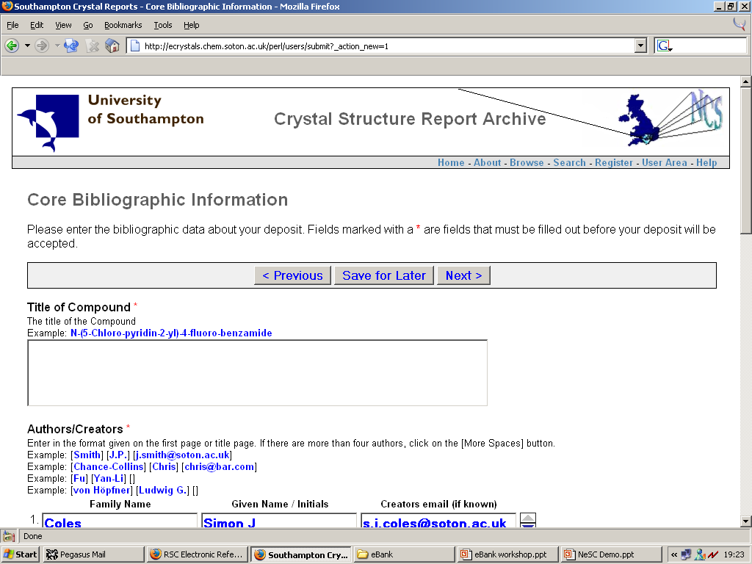

Figure 2: Deposition interface of the Crystal Structure Report Archive

The eBank Aggregator Service

This is a demonstrator service that uses the OAI-PMH to harvest metadata about datasets and scientific papers from third party data providers and to use this to provide a service to end users and other services. In the demonstrator, selected metadata is harvested from the Southampton eCrystals Repository and a sample set of records provided by a journal publisher and made available through a prototype user interface. Search fields include researcher names (authors), specific chemical information (CCDC Codes, IUPAC names, empirical formulae), subject keywords, and the release date. Results can be filtered by the compound class, the release date (for the most recent deposits), or by repository type (structure reports or papers). The results are presented to end users grouped in two columns, one for datasets and the other for journal articles. For more detailed metadata, the end user can link to the fuller description available from the data provider repositories. A version of the demonstrator was also 'embedded' in the PSIgate subject gateway using the existing CGI-Include mechanism developed and used by the Resource Discovery Network.

Available at: http://eprints-uk.rdn.ac.uk/ebank-demo/ and http://www.psigate.ac.uk/ebank/

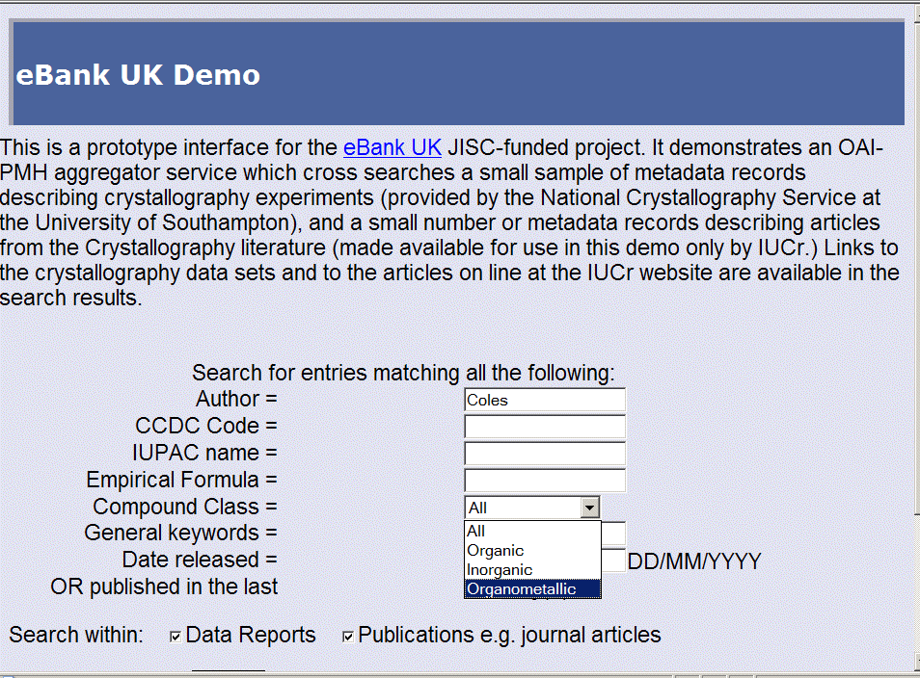

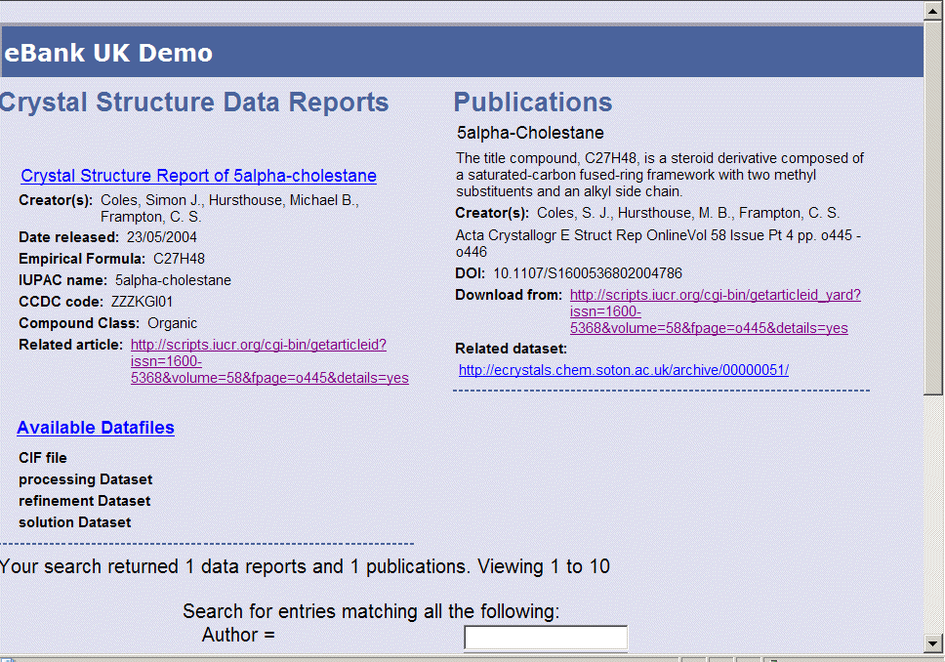

Figure 3: Main eBank demonstrator search and results interface

.

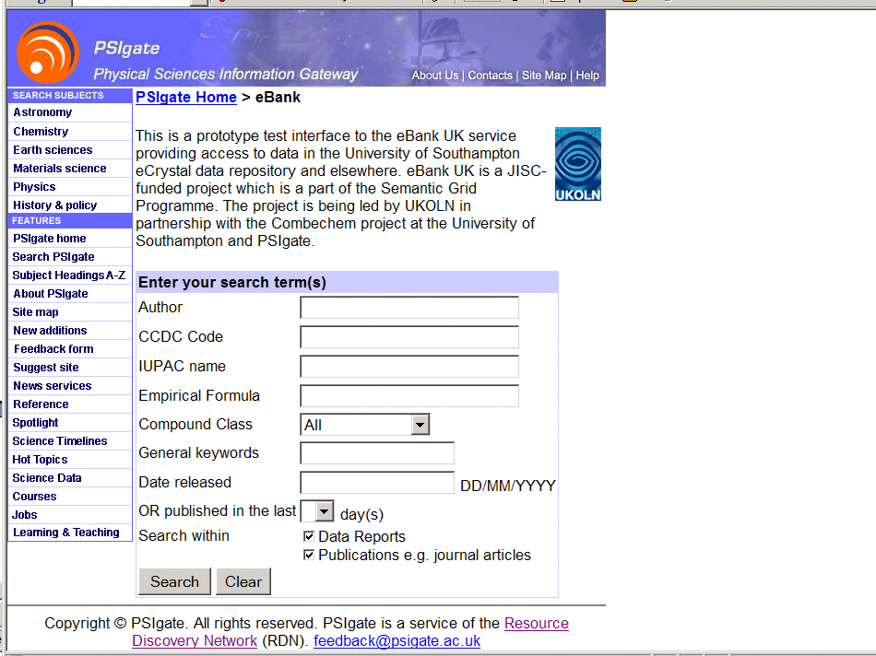

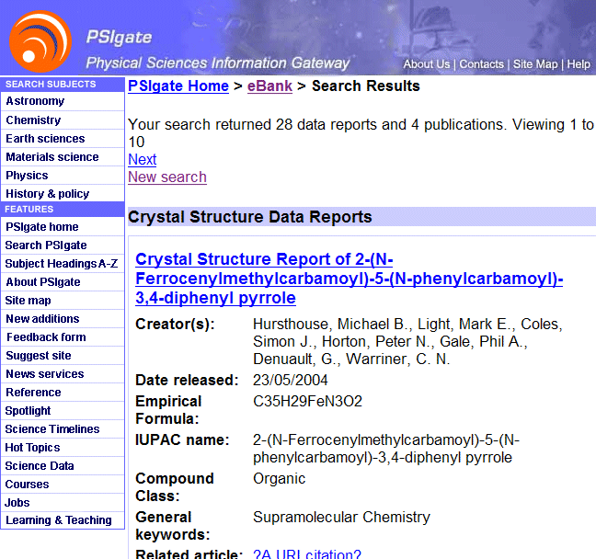

Figure 4: The results displayed through PSIgate with a modified ‘look and feel’

Evaluation

An Evaluation Workshop was held on the 5 August 2004 in Bath. The purpose of the event was to introduce the project's aims to an invited audience, to demonstrate the eCrystals Repository and eBank Aggregator services and to generate discussion.
A number of issues for the JISC were identified and it was noted that more work is needed in the following areas:

- Developing economic and business models. Additional services mean additional costs.
- Legal / rights issues. Data ownership/IP rights of re-use issues. Investigate use of ?Creative Commons?
- Wider political issues e.g. impact on RAE.
- Government support required following up on House of Commons Select Committee Report
- Developing a national infrastructure.
- Guidance on policies for implementing digital repositories.
- Identification of drivers for successful implementation of digital repositories
- Advocacy to institutions
- Persistent identifiers.
- Sustainability issues and problems with short-term project funding.

Full details of the other issues raised by participants can be found in the Evaluation Report (see Appendices). They included:

- sustainability and cost-benefits
- RAE requirements and pressures
- interdisciplinary differences
- IPR and data ownership
- Interactions with Dspace
- Improving the robustness of the software
- Workflow issues
- Diversity of data sets.

Documentation

Access to the eBank demonstrators and project documentation is provided via the eBank UK Web site http://www.ukoln.ac.uk/projects/ebank-uk/ . The public part of this site includes basic information on the project and its partners, the supporting studies, and general information on user requirements, metadata schemas used for scientific data, identifiers and citation, and data provenance. It also contains information on project dissemination activities, the eBank evaluation workshop, and reports of related events. In addition, there are links to and a walkthrough of the eBank prototype with some documentation.

The commented metadata schema and accompanying documentation is available online and can be downloaded from the links listed under the Appendices section.

Dissemination

The project has published papers and made presentations widely to a cross-section of communities from both digital libraries and eScience. The content of these works distils the lessons learnt and describes the progress made in different ways, e.g. through some descriptive images in the posters and presentations, as well as presenting the eBank work in the context of these other communities. Links to the all the publications and presentations are found on the project website.

Publications:

Rachel Heery, Monica Duke, Michael Day, Liz Lyon, Simon Coles, Jeremy Frey, Michael Hursthouse, Leslie Carr and Christopher Gutteridge.
Integrating research data into the publication workflow: eBank experience
PV-2004, Ensuring the Long-Term Preservation and Adding Value to the Scientific and Technical Data, European Space Agency, Frascati, Italy, 5-7 October 2004

Liz Lyon, Rachel Heery, Monica Duke, Simon Coles, Jeremey Frey, Michael Hursthouse, Leslie Carr and Christopher Gutteridge
eBank UK: linking research data, scholarly communication and learning
AHM 2004, eScience All Hands Meeting, Nottingham UK, 31 August-3 September 2004.

Presentations:

Liz Lyon
eBank UK - linking research data, scholarly communications and learning.
JISC CNI Conference, Brighton, July 2004.

Michael Day and Rachel Heery
eBank UK: linking scientific data, scholarly communication and learning
JISC Joint Programmes Meeting, Brighton, UK, July 6-7 2004.

Liz Lyon
Realising the scholarly knowledge cycle: the experience of eBank UK
CNI Task Force, Spring 2004, Alexandria, Virginia, USA, 15-16 April 2004.

Posters:

Simon Coles, Jeremy Frey, Michael Hursthouse, Leslie Carr and Christopher Gutteridge
Crystal Structure EPrints: Publication @ Source Through the Open Archive Initiative
ECM22, 22nd European Crystallographic Meeting, Budapest, Hungary, 26-31 August 2004

Simon Coles, Jeremy Frey, Michael Hursthouse, Leslie Carr and Christopher Gutteridge
eCrystallographyDataReports: an Open Archive Route for the Reporting and Dissemination of Crystal Structures
ISSC XIII, International Symposium on Supramolecular Chemistry, University of Notre Dame, South Bend, Indiana, USA, 25-30 July 2004

EBank UK Project JISC Joint Programmes Meeting, Brighton, UK, July 6-7 2004.

Simon J Coles, Jeremy G Frey, Michael B Hursthouse, Leslie A Carr, and Christopher J Gutteridge
Crystal Structure EPrints: Publication @ Source Through the Open Archive Initiative
British Crystallography Association Spring Meeting 2004, Manchester, UK, 6-8 April 2004.

Outcomes

“eBank will investigate the issues surrounding provenance and the use and re-use of original data for research and learning purposes, and will result in the development of an e-Bank UK pilot service for the benefit of the HE and FE communities.”

The eBank Project has made significant advances towards this overarching aim and progress against the deliverables stated in the original bid is summarised below:

Work Package | Description | Deliverables | Progress summary
1 | Stakeholder Requirements | Requirements specification | User scenarios captured.  User requirements specification completed.
2a | Pilot development | EPrints software technical requirements & development  Technical specification & schema | Software enhancements and schema complete subject to further testing.  Technical requirements  http://www.ukoln.ac.uk/projects/ebank-uk/docs/technical/requirements/  Technical specification  http://www.ukoln.ac.uk/projects/ebank-uk/docs/technical/aggregator-description/  XML schema  http://www.rdn.ac.uk/oai/ebank/20040611/ebank_dc.xsd  http://www.rdn.ac.uk/oai/ebank/20040611/ebankterms.xsd
3 | Pilot service | Demonstration service | Web interface completed  http://eprints-uk.rdn.ac.uk/ebank-demo/
4 | Pilot testing & embedding | Interoperability with PSIgate | PSIgate embedding completed. Demonstrator services presented at All Hands Meeting in September and eBank UK workshop (August)
5 | Repository deployment & compliance | Depositing e-prints and data and ensuring data providers OAI-compliance | Prototype OAI data archive completed.  Sample data and metadata deposited.
6 | Supporting studies | Report on provenance  Feasibility Report on dataset description and Schema | First draft (negotiating to carry over to project phase2)  Final draft completed.
7 | Evaluation & Recommendations | Consultation workshop  Evaluation report  Recommendations for future work | Workshop held in August. Summary outcomes document  eBank Phase 2 proposal submitted to JSR and approved September 2004.
8 | Project management | Summary Final Report | Draft submitted to JISC November 2004.

Summary of Outcomes

We have:

- Demonstrated proof of concept in linking research data to e-prints and scientific papers derived from the data in the domain area of crystallography.
- Developed a repository demonstrator based on the EPrints.org software which contains datasets from crystallography experiments.
- Developed the eBank Aggregator Service demonstrator based on the ePrints UK architecture which harvests metadata about datasets and scientific papers from third party providers.
- Embedded the Aggregator Service within the Resource Discovery Network PSIgate portal as one potential link and access point for learners.
- Identified and explored vocabulary differences between the different communities i.e. computer scientists, information / digital library practitioners and chemists.
- Raised international awareness of the implications of linking data through a consultation workshop with stakeholders and through a number of presentations and publications to the wider community.
- Produced a programme of follow-on development activity to extend and build on the results of Phase 1 of the project.

Conclusions

Our development activities and discussions during the 12-month funding period have highlighted the challenges and complexities of working in a cross-domain area, both in terms of understanding the nature of the chemistry data and its management, but also in terms of the different “landscape views” of the communities involved. We have identified a common and shared commitment to the importance of enabling open access to data from e-research applications and have been pleased to see our work stimulating interest and excitement both within the chemistry community and in the wider sector.

Implications

Our proposals for continuing this work and building on the pilot service are outlined in the Phase 2 project proposal and are summarised below.

Phase 2 has 4 key objectives:
- To seek consensus within the community on the development of a generic data model and metadata schema for scientific data.
- To assess the pedagogical benefits of access to primary e-research data within associated e-learning materials in the taught postgraduate curriculum in chemistry.
- To investigate expansion of the eBank service in other sub-disciplines of chemistry and the physical sciences.
- To test the feasibility of implementing eBank in the related domain area of the biosciences.

The potential longer-term implications can also be summarised:

- Track data, information and workflows in e-research and associated scholarly communications i.e. demonstrate a knowledge audit mechanism.
- Validate the accuracy and authenticity of derived works i.e. demonstrate an ideas audit mechanism.
- Facilitate explicit referencing and acknowledgment of original contributors i.e. support intellectual integrity.
- Raise standards associated with publication of research outputs i.e. improve academic publishing rigour.
- Implement open access to and dissemination of data and information i.e. enhance the research process.
- Give students links to original data underpinning published works i.e. enrich the learning process.

References

[1] L. Lyon, "eBank UK: building the links between research data, scholarly communication and learning." Ariadne, 36, 2003. Retrieved October 12, 2004, from: http://www.ariadne.ac.uk/issue36/lyon/
[2] F.H. Allen, "The Cambridge Structural Database: a quarter of a million crystal structures and rising." Acta Crystallographica, vol. B58, 380-388, 2002.
[3] C. Lynch, “Institutional repositories: essential infrastructure for scholarship in the digital age,” ARL Bimonthly Report, no. 226, February 2003. Retrieved October 12, 2004, from: http://www.arl.org/newsltr/226/ir.html
[4] R. Crow, The case for institutional repositories: a SPARC position paper. Washington, D.C.: Scholarly Publishing & Academic Resources Coalition, 2002. Retrieved October 12, 2004, from: http://www.arl.org/sparc/IR/ir.html
[5] Open Archives Initiative Protocol for Metadata Harvesting, version 2.0, June 2002. Retrieved October 12, 2004, from: http://www.openarchives.org/
[6] arXiv.org. Retrieved October 12, 2004, from: http://arxiv.org/
[7] CogPrints. Retrieved October 12, 2004, from: http://cogprints.ecs.soton.ac.uk/
[8] ePrints UK. Retrieved October 12, 2004, from: http://www.rdn.ac.uk/projects/eprints-uk/
[9] GNU EPrints Archive Software. Retrieved October 12, 2004, from: http://software.eprints.org/
[10] S.R. Hall, F.H. Allen and I.D. Brown, “The Crystallographic Information File: a new standard archive file for crystallography,” Acta Crystallographica, vol. A47, pp. 655-685, 1991.
[11] I.D. Brown and B. McMahon, "CIF: the computer language of crystallography." Acta Crystallographica, vol. B58, 317-324, 2002.
[12] International Union of Crystallography. Retrieved October 12, 2004, from: http://www.iucr.org/
[13] PSIgate. Retrieved October 12, 2004, from: http://www.psigate.ac.uk/
[14] IUPAC-NIST Chemical Identifier (INChI). Retrieved October 12, 2004, from: http://www.iupac.org/projects/2000/2000-025-1-800.html
[15] Cheshire SGML search engine. Retrieved October 12, 2004, from: http://cheshire.berkeley.edu/
[16] SRW Search/Retrieve Web Service. Retrieved October 12, 2004, from: http://www.loc.gov/z3950/agency/zing/srw/
[17] NISO Committee AX. Retrieved October 12, 2004, from: http://library.caltech.edu/openurl/
[18] Dublin Core Metadata Initiative, Dublin Core Metadata Element Set, version 1.1, DCMI Recommendation, June 2003. Retrieved October 12, 2004, from: http://dublincore.org/documents/dces/
[19] Dublin Core Metadata Initiative, DCMI Metadata Terms, DCMI Recommendation, June 2004. Retrieved October 12, 2004, from: http://dublincore.org/documents/dcmi-terms/
[20] M. Guy, A. Powell and M. Day, "Improving the quality of metadata in eprint archives." Ariadne, 38, 2004. Retrieved October 12, 2004, from: http://www.ariadne.ac.uk/issue38/guy/
[21] A. Powell, M. Day and P. Cliff, "Using simple Dublin Core to describe eprints," v. 1.2, 2004 Retrieved October 12, 2004 from: http://www.rdn.ac.uk/projects/eprints-uk/docs/simpledc-guidelines/
[22] B. Matthews and S. Sufi, S. "The CLRC Scientific Metadata Model - Version 1." Technical Report DL TR 02001. Warrington: CLRC Daresbury Laboratory, 2001. Retrieved October 12, 2004 from: http://www-dienst.rl.ac.uk/library/2002/tr/dltr-2002001.pdf
[23] S. Sufi, B. Matthews and K. Kleese van Dam, “An interdisciplinary model for the representation of scientific studies and associated data holdings.” UK e-Science All Hands Meeting, Nottingham, UK, 2-4 September 2003. Retrieved October 12, 2004, from: http://www.nesc.ac.uk/events/ahm2003/AHMCD/pdf/020.pdf
[24] P. Buneman, S. Khanna, and W.-C. Tan, W. -C. "Why and where: a characterization of data provenance." In: Database theory - ICDT 2001: 8th international conference, London, UK, January 4-6, 2001. Lecture Notes in Computer Science, 1973, pp. 316-330. Berlin: Springer-Verlag, 2001. Retrieved October 12, 2004 from: http://db.cis.upenn.edu/DL/whywhere.pdf

Appendixes

Requirements for the cross-searching web interface for eBank UK
http://www.ukoln.ac.uk/projects/ebank-uk/docs/technical/requirements/

Technical Description of the eBank UK aggregator Service
http://www.ukoln.ac.uk/projects/ebank-uk/docs/technical/aggregator-description/

Metadata schema for the exchange of metadata between OAI-PMH repositories and harvesters.
XML Schemas:
http://www.rdn.ac.uk/oai/ebank/20040611/ebank_dc.xsd
http://www.rdn.ac.uk/oai/ebank/20040611/ebankterms.xsd
Guidelines for use in crystallography:
http://www.ukoln.ac.uk/projects/ebank-uk/schemas/ebank-schema.doc

EBank UK project scenarios and user requirements
http://www.ukoln.ac.uk/projects/ebank-uk/requirements/scenarios.html

Evaluation Report
http://www.ukoln.ac.uk/projects/ebank-uk/workshop/

Report on Provenance Issues
http://www.ukoln.ac.uk/projects/ebank-uk/provenance/

Feasibility Report on Data Set Description and Schema
http://www.ukoln.ac.uk/projects/ebank-uk/schemas/feasibility/

