Digitization of Old Analogue Geomagnetic Data

T. Iyemori, M. Nose, H. McCreadie, Y. Odagi, M. Takeda, T. Kamei and M. Yagi
Data Analysis Center for Geomagnetism and Space Magnetism,
Graduate School of Science, Kyoto University, Kyoto 606-8501, Japan.
iyemori@kugi.kyoto-u.ac.jp
1. Introduction

Continuous geomagnetic observation started in the middle of the 19th century and has produced a huge number of magnetograms (records of geomagnetic variations) recorded on photographic paper. Old geomagnetic data are essential for obtaining geomagnetic secular variation to investigate the geo-dynamo mechanism. Since geomagnetic disturbances are closely related to solar activity, a long series of geomagnetic data can also give us independent information on long-term variations in processes on the Sun’s. Solar activity is also known to the affect climate change, therefore old geomagnetic data are also useful for investigating climate change.
Currently, most of the original magnetograms are kept at each observatory. After the International Geophysical Year, 1957-1958 (IGY) when the World Data Center (WDC) system was established under ICSU (International Council for Science), microfilmed copies of magnetograms were exchanged and kept at the WDCs for geomagnetism or the WDCs for Solar-Terrestrial Physics. However, for researchers to access the microfilm they must travel to one of the WDCs. This is costly and time consuming.
Figure 1 shows the number of observatories which provided analogue magnetograms (Normal-run magnetograms) and/or digital magnetic data with 1 minute resolution to the WDC-Kyoto. The sudden increase in observatories after 1957 indicates how the IGY and establishment of the World Data Center system effectively promoted magnetic observation and data exchange over the world. It is also seen that a digital era in geomagnetic observation started around middle of the 1980s. It should be noted that, the amount of analogue data, i.e., (Number of stations x Period of observation), is still much more than that of digital data. The preservation of the huge number of old microfilms is becoming more difficult as the film ages. It is desirable to convert the microfilms to digital form not only for preservation but also for making them useful and valuable in this era of computational analysis.

Figure 1. Analogue and digital data collection at WDC-Kyoto.

Taking into account the change of user requests, i.e., from paper and microfilm copies to digital files, and the importance of old geomagnetic records, we have been trying to digitize magnetic data in the last several years: Observatory year books contain average hourly values widely used by researchers. These are being hand-typed; Microfilmed magnetograms are being scanned; and since last year, we started making digital image files from original paper magnetograms using a digital camera. Here we report our recent activities in geomagnetic database construction including the project of IAGA's “Rescue of Old Analogue Magnetograms by Converting to Digital Images” for the study of geospace climatology.

2. Hourly values
Geomagnetic hourly values have been scaled and published mostly in the form of year books from each observatory, and most of the books are kept at the WDCs. The efforts to convert the printed tables in the books to a computer readable format have been done for many years and we have a database which covers a long period and a wide geographic area (http://swdcwww.kugi.kyoto-u.ac.jp/hyplt/index.html). However, there still remain many data books which have not yet been digitized and the efforts continue. To store digitized hourly values is easy because the total space necessary to store the available data, including data that needs to be digitized, amounts to a few Giga-Bytes. The data are stored as ASCII files.

3. Measurements of the Earth’s magnetic field.
The most common method of measuring the Earth’s magnetic field is to use a magnetic variometer. Before the digital era, the recordings were made on photographic paper as schematically depicted in Figure 2. Nowadays, most of the measurements around the globe are digital. Each variometer records three orthogonal components of the Earth’s magnetic field as it changes with time. Shown in Figure 3 are the orientation of the magnetics attached to fibres which measure variations in the Declination (D), Horizontal (H) and vertical (Z) components of the Earth’s magnetic field. The same principles apply to modern variometers.

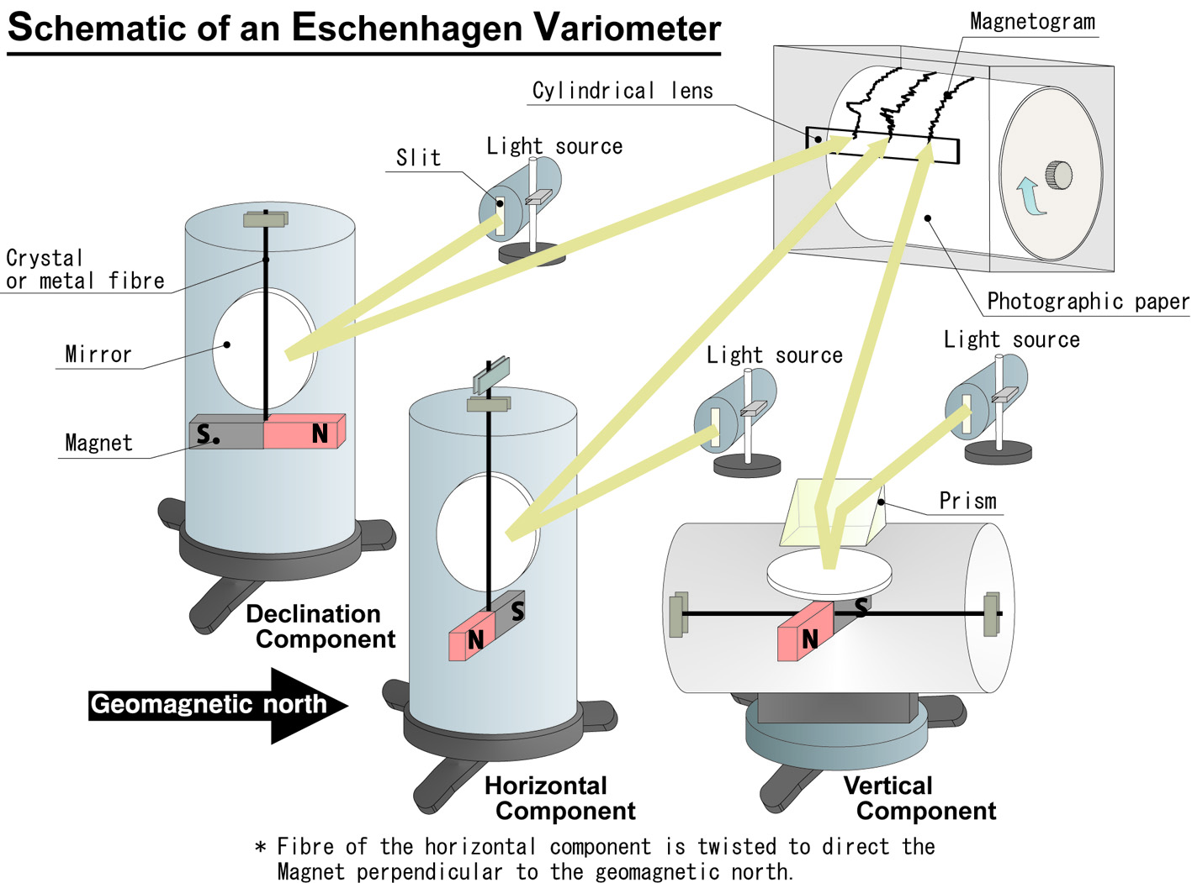
Figure 2. Principle of analogue magnetic measurement with Eschenhagen type variometer.

4. Analogue magnetograms
Figure 3 is an example of an analogue magnetogram from Kakioka magnetic observatory on January 1st, 1974. The original magnetogram was transferred to microfilm which was then stored at the WDC. What is shown in Figure 3 is an image scanned from the microfilm. Three lines show the Horizontal (upper trace), Declination (lower trace) and Vertical (middle trace) components of geomagnetic field for one day in Universal Time (UT).

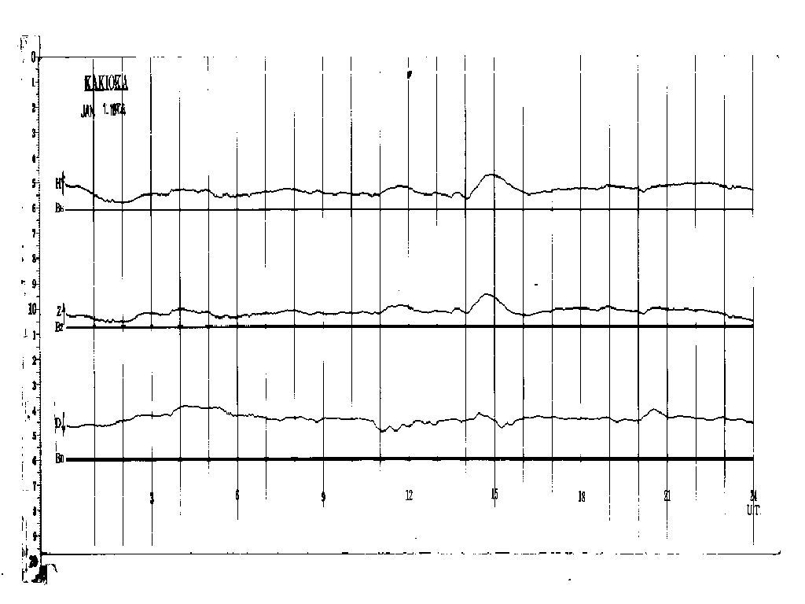
Figure.3 A magnetogram obtained from Kakioka geomagnetic observatory on January 1st, 1974.

At the WDC for Geomagnetism, Kyoto, about 9000 reels of 35mm microfilmed magnetograms are archived (including some duplicates). Most are records after the IGY: The original magnetograms are kept in each country. A big advantage of microfilmed magnetograms is that the meta-data (scale values and base line values) which are necessary for analysis are also recorded on the same microfilm reels. This is not true for original magnetograms where the meta data are written in separate log books or observers diaries and are sometimes lost. On the other hand, a disadvantage of microfilm is some loss of quality from the original magnetograms caused by distortion of the frame of the microfilm.

5. Conversion to digital image files
In the last several years, we have been constructing digital image files from microfilmed magnetograms and some of them are available at our web site (http://swdcft49.kugi.kyoto-u.ac.jp/film/index.html ). For example, the old magnetograms from 1924 to 1975 obtained at Kakioka Observatory, Japan are available. The resolution of the microfilm scanner is 6592x4672 pixels for 35mm microfilms. Therefore, the maximum time resolution attainable for normal run magnetograms which usually cover 24 hours in one frame is 0.2 minutes per pixel. Accounting for 30% of the scan being margin space the actual resolution is closer to 0.3 minutes per pixel.
Since the microfilmed magnetograms are mainly for the period after IGY, the WDC panel has been conducting the “Data Rescue Project” to make microfilm copies of original magnetograms including those before 1900. As part of this project, since 2003, we began making digital image files from photographic paper magnetograms using high-resolution digital cameras as part of the IAGA project. The camera resolution is 2560x1920 pixels, making the maximum attainable time resolution per magnetogram 0.5 minutes per pixel. Accounting for 30% of the scan being margin space the actual resolution is closer to 0.8 minutes per pixel: still within the required one minute time resolution.
The files containing the digital images are in Tiff format which keeps the original scanned/photographed information without any loss. However, the original files also contain dark speckles resulting from; reflections from dust particles at the time the original magnetogram was collected, dust when the photograph was taken and if microfilm is used, deterioration of the microfilm (see figure 4). This noise is removed using a filter which acts on specific clusters of back pixels. If a given cluster of black pixels consists of less than 16 pixels, that cluster is removed (or replaced it with white pixels). This filter is termed the sesame seed algorithm because of the speckles resemble sesame seeds. The size of the raw TIFF files is typically a few MB. We can reduce the size to a few tenths of MB (~1/10 of original size) with our sesame seed algorithm. For web services and preservation of very large number of digital image files, it is desirable for the file size to be as small as possible without losing necessary information.

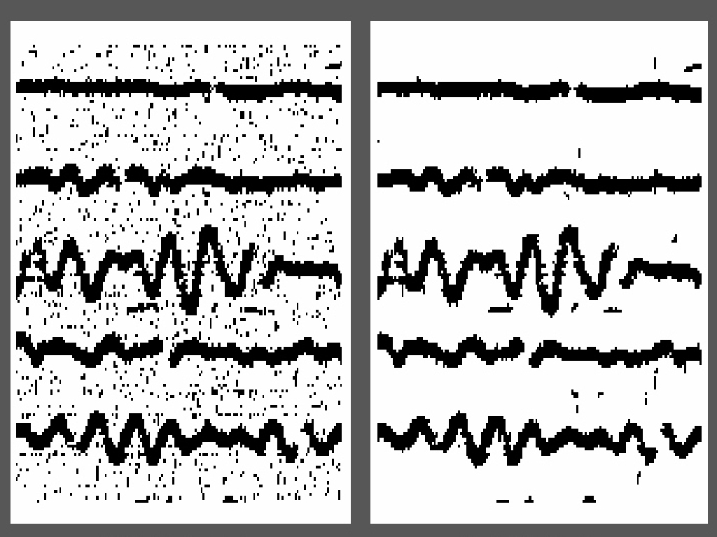

Figure 4. By removing the dots and unnecessary parts on each frame and compressing the Tiff file, the size is reduced to, on average, one tenth of the original one without loss of data.

6. Web service of image files, preservation of them and future plan
The processed image files are tagged with necessary information such as the date and station names and put on a disk array system in Tiff format and they are available from our web site ( http://swdcft49.kugi.kyoto-u.ac.jp/film/index-j.html ). Because the total number of image files (~350,000 to date totaling ~90GB) is too large to transfer via the Internet, they are copied on CDs (or DVDs) and sent to other WDC’s for geomagnetism and solar-terrestrial physics, for preservation.
We plan to cover a more extensive period and region with the digital magnetogram image files as well as develop software to trace the magnetogram and generate digital data.

Acknowledgments
We thank Dr Y. Futaana and Dr. A. Saito for their technical help in developing the method of noise reduction in the image files. The construction of image file database has been supported in part (as "Solar-Terrestrial Physics Database") by grant 127008, 168069 and 178061 under the Japan Society for Promotion of Science (JSPS), and 2003 ICSU grant for “Rescue of Old Analogue Magnetograms by Converting to Digital Images”. We also thank many geomagnetic observatories, institutions and international organizations that kindly supply the data to the WDC system.

