UKOLN




Exercise 3

An Introduction to Web 2.0 and the Social Web

Exercise 3 - Using Social Bookmarking and Sharing Services
Summary
Social bookmarking sites allow users to store URL links and share them with others.
In this exercise you will make use of a number of social bookmarking tools and social sharing tools.
On completion of this session the learner will have a better understanding of social bookmarking and sharing Services.
Prerequisites
Users will need access to networked PCs and access to the Delicious site at <http://delicious.com/>
Tasks
- Using Delicious
Go to the Delicious social bookmarking service at the address: <http://delicious.com/>.
Familiarise yourself with the tool.
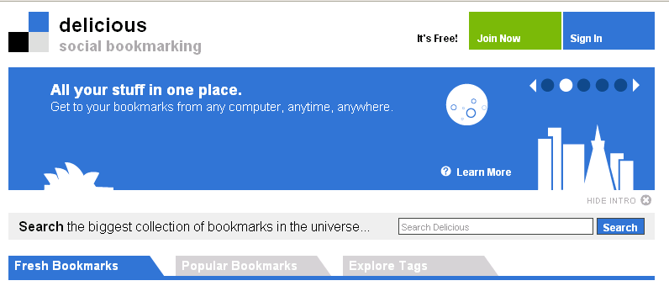
Click on the Explore Tags tab. Tagging your links is one of the most important things you can do. It gives semantic value to your bookmarks and helps you retrieve them more easily.
Which of the most popular tags are of interest to you?

- Delicious Users
Go to the page <http://delicious.com/mariekeguy/mla-social-web-workshop> and look at the resources which have been bookmarked.
Find the Delicious bookmark entry for Lorcan Dempsey's weblog.
Notice how many others have bookmarked this page (the blue box with a number in at the end of the line). Click on the number and have a look at some of the comments made about the blog.
Explore the resources which have been bookmarked by people who have also bookmarked this entry.
- Setting up a Delicious Account
If you are happy to set up a Delicious account click on the Join Now link on the top right hand side.
Once you have set up an account click on the Save a new bookmark link on the top right hand side and type in your home page URL.
When adding tags consider the recommended tags offered.
- Connotea
Go to the Connotea bookmarking service at the address <http://www.connotea.org/>
What would you consider are the main differences between this bookmarking tool and Delicious?

- Flickr
Go to the Flickr photo sharing service at <http://www.flickr.com/>.
Find photographs which have been tagged with the term “archive”, “museum” or “library”.
How many photographs are available?
Continue searching for photographs which may be of interest to you.

- Flickr Searching
After carrying out a search using Flickr click on the advanced search link to the right of the search button.
Scroll down to the Creative Commons section and modify your search to only include content you can modify, adapt, or build upon.
- Use Of Social Sharing Services
What, if any, potential do social bookmarking and photographic sharing services have for your organisation?

- Advantages and Disadvantages
What are the advantages and disadvantages of using these type of social sharing tools??
Advantages | Disadvantages

Comments
Delicious is a very user-friendly way to store and share your bookmarks. There are browser add-ons for both Internet Explorer and Firefox. There are options to bundle tags and use subscriptions services to find related links. You can also embed Delicious links into Web pages or blogs.

