UKOLN




Exercise 4

An Introduction to Web 2.0 and the Social Web

Exercise 4 – Seeing how your Organisation is portrayed Online
Summary
Organisations no longer have control over how the public sees their organisation online.
In this session you will look at how your organisation is currently portrayed online and give some thought to what you can do to improve its image.
On completion of this session the learner will have a better understanding of using some online tools.
Prerequisites
Users will need access to networked PCs and access to Twitter.
Tasks
- Wikipedia
Go to the Wikipedia home page at the address:
<http://en.wikipedia.org/wiki/Main_Page>.
Carry out a search for your organisation.
You may wish to use one of the following:
<http://en.wikipedia.org/wiki/List_of_museums_in_England>
<http://en.wikipedia.org/wiki/List_of_libraries>
<http://en.wikipedia.org/wiki/List_of_archives>
- Is there an entry for it?
- Is it accurate?
- Is it appealing?
Check the history of the entry:
- When was it created?
- How has it changed?
- What did the original entry say? Was this a good representation of your organisation?
- 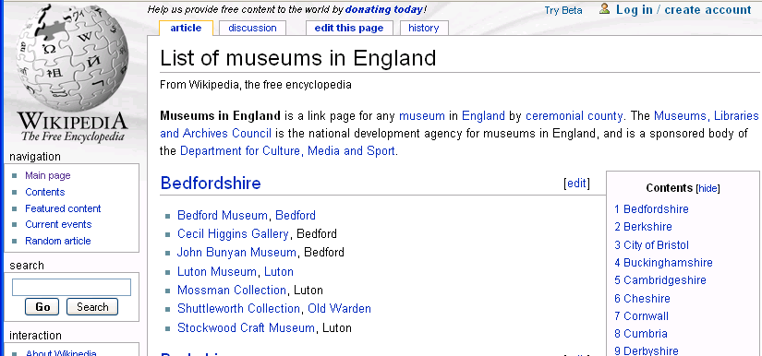
- Facebook
Go to the Facebook home page at the address:
<http://www.facebook.com >.
Carry out a search for your organisation.
- Are there any groups or pages for it?
- Is it clear which is the authoritative page?
- Does the main page have a vanity url?
- Is the page/group active?

- Advantages and Disadvantages of Facebook
What are the advantages and disadvantages of using Facebook as a way to communicate with users?
Advantages | Disadvantages
- YouTube
Go to the YouTube home page at the address:
< http://www.youtube.com/>.
Carry out a search for your organisation.
- Are the top hits made by your organisation or made externally?
- Do they paint a good picture of your organisation?

If you have time you can also try searching <http://www.bebo.com/>, <http://uk.myspace.com/> and <http://www.ratethismuseum.com/>
- Marketing Strategy
Give some thought to easy strategies for improving the image of your organisation.

Comments
How you are portrayed online makes a big difference to how users see your organisation.

