UKOLN




Exercise 1

An Introduction to Web 2.0 and the Social Web

Exercise 1 - Using an Externally Hosted Wiki Service
Summary
Wikis are Web sites that allow collaborative working.
In this session you will look at a simple wiki tool called Wetpaint.
On completion of this session the learner will have a better understanding of wiki features.
Prerequisites
Users will need access to networked PCs and access to the WetPaint Wiki at <http://www.wetpaint.com/>.
Tasks
- Workshop Wiki
Go to the Wiki page at the address:
< http://ukoln-social-web-workshops.wetpaint.com/>.
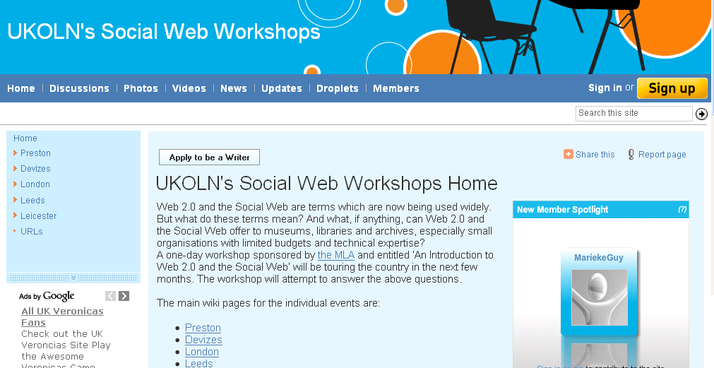
Navigate around the Wiki site and look at the pages available for your event.
- Adding Information
On the workshop Wiki add some information about yourself. Either add something to the Delegates page for your workshop or try creating a new page and link to it.
- Uses for a Wiki
In your Wetpaint wiki space make a note of possible uses this Wiki could have in your organisation.

- Strengths and Weaknesses
Consider the strengths and weaknesses of using this particular Wiki service.
Strengths | Weaknesses
- Comparing Wiki Services
Other free wiki services include:
- PBWorks: <http://my.pbworks.com/>
- Wikidot: <http://www.wikidot.com/>
- MediaWiki: <http://www.mediawiki.org/wiki/MediaWiki>
- Wikispaces: <http://www.wikispaces.com/>
In you have time take a look at these other services and consider the differences.
- Comparing Wiki Features
Have a quick look at the Wikipedia page comparing wiki software. <http://en.wikipedia.org/wiki/Comparison_of_wiki_software>
Some of the features compared include: File uploading, spam prevention, page access control, user-customizable interface, document renaming, WYSIWYG editing, Web feeds and extensibility.
What features would you find useful for possible work Wikis?

- Advantages and Disadvantages
What are the advantages and disadvantages of using an externally hosted wiki service such as Wetpaint?
Advantages | Disadvantages

Comments
Wetpaint is an example of an externally hosted wiki service. It is very easy to set up a Wetpaint Wiki and use requires no specialist skills. In addition access to the Wiki can be restricted to authorised users.
However if you are considering making use of externally hosted services you will need to address certain potential risks, such as the persistency, performance and interoperability of the service.

