Exercise 9: Using Netvibes To Read and Manage RSS Feeds



A UKOLN Document

Aims Of This Exercise
In the following exercises you will use the Web-based Netvibes tool to view and manage RSS feeds.

9.1 Using Netvibes
Go to the address: <http://www.netvibes.com/>.
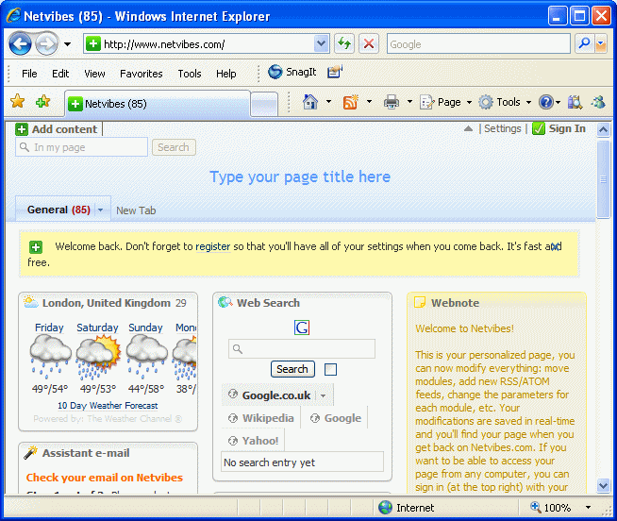
Familiarise yourself with how the service works by, for example, viewing BBC news items.

9.2 Adding New Content To Netvibes
Click on the General tab to return to the Netvibes home page.
What are the advantages and disadvantages of doing this?
Then click on the Add content link on the top left hand corner. Then open the Featured Feeds or Feeds Directory elements under the Widgets section of the left hand menu.
Select an RSS feed. Notice how it is automatically added to the main area of the Netvibes page.
Summary: You have added an RSS feed to a personalised page on Netvibes. However you will need to register (for free) if you wish Netvibes to remember your personalised options.

Exercise 9: Using Netvibes To Read and Manage RSS Feeds

A UKOLN Document

Aims Of This Exercise
In the following exercises you will use an OPML viewer to view RSS feeds which are embedded in a Web site.

9.1 Using Netvibes
Go to the address: <http://www.netvibes.com/>.
Familiarise yourself with how the service works by, for example, viewing BBC news items.

9.2 Adding New Content To Netvibes
Click on the General tab to return to the Netvibes home page.
What are the advantages and disadvantages of doing this?
Then click on the Add content link on the top left hand corner. Then open the Featured Feeds or Feeds Directory elements under the Widgets section of the left hand menu.
Select an RSS feed. Notice how it is automatically added to the main area of the Netvibes page.
Summary: You have added an RSS feed to a personalised page on Netvibes. However you will need to register (for free) if you wish Netvibes to remember your personalised options.

9.3 Adding New RSS Feeds To Netvibes
Click on the General tab to return to the Netvibes home page and then the Add content option (if it is not already open). Then click on the Add a feed option.
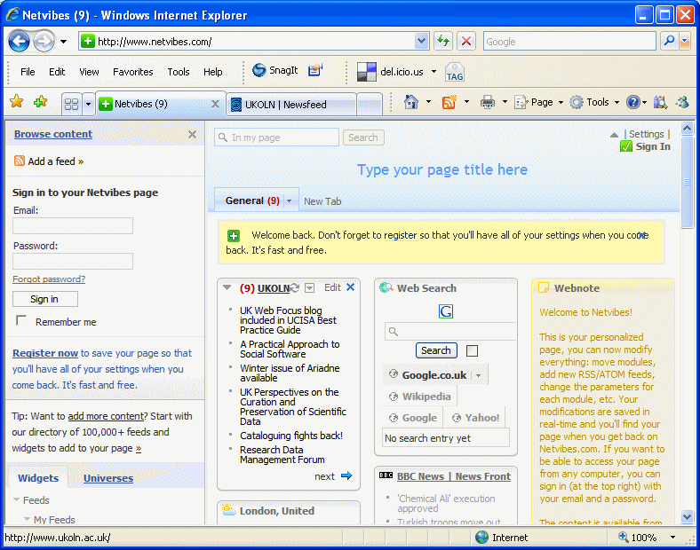
Enter the URL of an RSS feed. If you do not have a feed available you can use http://www.ukoln.ac.uk/news/feed/rss/
The RSS feed should be added to the main area of Netvibes as shown.

9.4 Personalising Netvibes
If you wish to make further use of Netvibes you can sign up for free using your email account. Once registration is completed you can add your favourite RSS feeds. Whenever you revisit Netvibes any new RSS content will be displayed automatically.
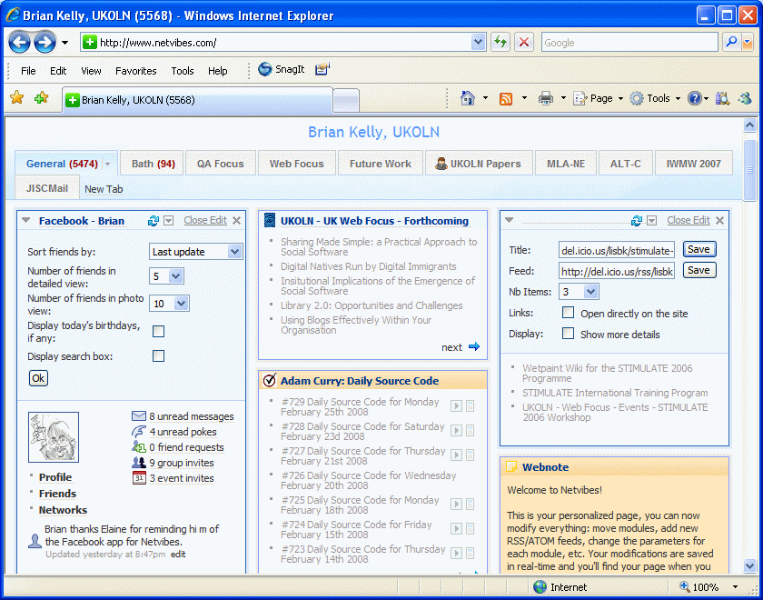
Also note that you can embeed podcasts, interfaces to services such as Facebook, add multiple tabs, etc. in Netvibes.

9.3 Adding New RSS Feeds To Netvibes
Click on the General tab to return to the Netvibes home page and then the Add content option (if it is not already open). Then click on the Add a feed option.
Enter the URL of an RSS feed. If you do not have a feed available you can use http://www.ukoln.ac.uk/news/feed/rss/
The RSS feed should be added to the main area of Netvibes as shown.

9.4 Personalising Netvibes
If you wish to make further use of Netvibes you can sign up for free using your email account. Once registration is completed you can add your favourite RSS feeds. Whenever you revisit Netvibes any new RSS content will be displayed automatically.
Also note that you can embeed podcasts, interfaces to services such as Facebook, add multiple tabs, etc. in Netvibes.

