Exercise 5: Staff Development To Support Use Of Web 2.0 Technologies



A UKOLN Document

Aims Of This Exercise
In this exercise you find out how Web 2.0 technologies, such as blogs, podcasts, etc. can be used to provide training and staff development for users and developers of Web 2.0 tools and services.

5.1 Tame The Web
Go to the Tame TheWeb Blog at the address: <http://tametheweb.com/>.
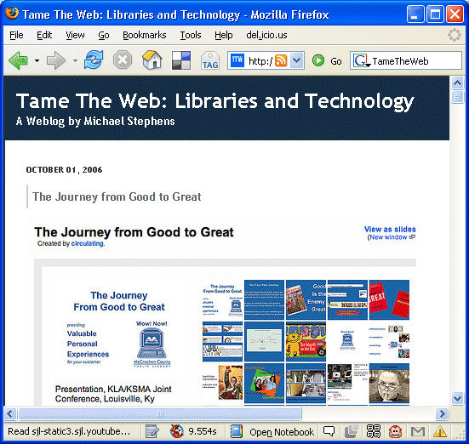
Read some of Michael Stephens’ postings about Web 2.0 technologies and their potential in the Library world.

5.2 Tame The Web Postings On Training And Top Trends
Scroll through the menu of the right hand side of the window until your find the list of categories for thew Blog postings.
Read some of the postings which have been categorised under “Training” and “Top Tech Trends”.

Exercise 5: Staff Development To Support Use Of Web 2.0 Technologies

A UKOLN Document

Aims Of This Exercise
In this exercise you find out how Web 2.0 technologies, such as blogs, podcasts, etc. can be used to provide training and staff development for users and developers of Web 2.0 tools and services.

5.1 Tame The Web
Go to the Tame TheWeb Blog at the address: <http://tametheweb.com/>.
Read some of Michael Stephens’ postings about Web 2.0 technologies and their potential in the Library world.

5.2 Tame The Web Postings On Training And Top Trends
Scroll through the menu of the right hand side of the window until your find the list of categories for thew Blog postings.
Read some of the postings which have been categorised under “Training” and “Top Tech Trends”.

5.3 Podcasts
Go to the Library 2.0 Podcasts Blog at <http://podcasts.alablog.org/blog/>.
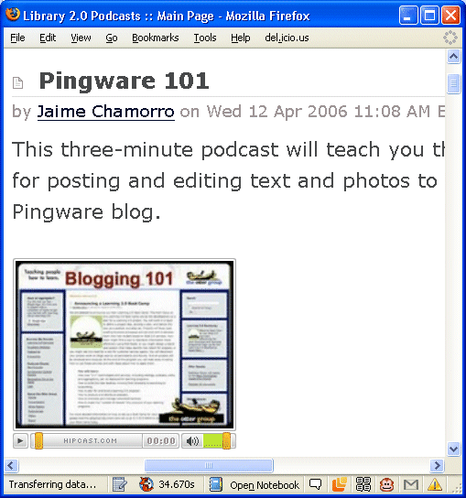
Read about the Podcasts, the typical length and the topics they cover.
What are the advantages of such Podcasts?

What are the limitations?

How could the Podcasts be used to support learning and professional development?

5.4 Use Of Video
Visit the Seesmic video post on “Video blog 1: Why I Blog” at <http://seesmic.com/video/FTBVslEUqL>.
If you have a Webcam you can give a video response to this video post.
You can also make use of vidoe clips from services such as Seesmic, YouTube, Google Video, etc. in your trainingand staff development courses and for personal development.

5.5 Creative Commons
Check the licence conditions for the training resources mentioned above, such as the Seesmic video posts.
You may find a Creative Commons logo (as illustrated). This grants you permission to make use of the materials, subject to conditions such as, perhaps, no commercial reuse.
What are the potential advantages and limitations in Creative Commons licences to support staff development and training, especially in the public sector?

5.3 Podcasts
Go to the Library 2.0 Podcasts Blog at <http://podcasts.alablog.org/blog/>.
Read about the Podcasts, the typical length and the topics they cover.
What are the advantages of such Podcasts?

What are the limitations?

How could the Podcasts be used to support learning and professional development?

5.4 Use Of Video
Visit the Seesmic video post on “Video blog 1: Why I Blog” at <http://seesmic.com/video/FTBVslEUqL>.
If you have a Webcam you can give a video response to this video post.
You can also make use of vidoe clips from services such as Seesmic, YouTube, Google Video, etc. in your trainingand staff development courses and for personal development.

5.5 Creative Commons
Check the licence conditions for the training resources mentioned abovee, such as the Seesmic video posts.
You may find a Creative Commons logo (as illustrated). This grants you permission to make use of the materials, subject to conditions such as, perhaps, no commercial reuse.
What are the potential advantages and limitations in Creative Commons licences to support staff development and training, especially in the public sector?

