UKOLN CulturalHeritage Blog


About the UKOLN Cultural Heritage Blog
The UKOLN Cultural Heritage blog is managed by Ann Chapman as part of the UKOLN Cultural Heritage Web pages. Ann works for UKOLN, a national centre of expertise in digital information management, located at the University of Bath which is funded by the JISC.
The blog is available at the URL < http://blogs.ukoln.ac.uk/cultural-heritage/>.

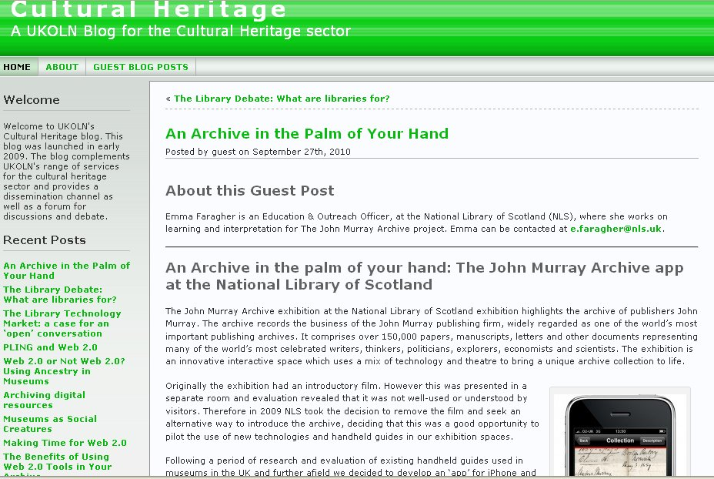

Scope of the Blog
The main audiences of the blog include developers, content creators, designers and policy makers across the UK’s cultural heritage sector, together with key players in the international community. The blog primarily seeks to address issues related to the networked information services and their implications for the sector.
UKOLN CulturalHeritage Blog

About the UKOLN Cultural Heritage Blog
The UKOLN Cultural Heritage blog is managed by Ann Chapman as part of the UKOLN Cultural Heritage Web pages. Ann works for UKOLN, a national centre of expertise in digital information management, located at the University of Bath which is funded by the JISC.
The blog is available at the URL < http://blogs.ukoln.ac.uk/cultural-heritage/>.

Scope of the Blog
The main audiences of the blog include developers, content creators, designers and policy makers across the UK’s cultural heritage sector, together with key players in the international community. The blog primarily seeks to address issues related to the networked information services and their implications for the sector.
Early content focused on news items and reflective pieces by UKOLN staff on a range of aspects related to the Web and networked information services. Since April 2010 most of the content has been in the form of guest posts from practitioners writing about their own experiences.
Topics covered in recent blog posts include making time for Web 2.0 [1], using a wiki as a staff development tool [2] and an iPHone app for an archival collection [3].

Aims Of The Blog
The main aims of the blog are:
Communication Channel: The blog aims to provide a key communication channel for UKOLN’s engagement with the cultural heritage sector.
User engagement: The blog seeks to encourage discussion and debate on innovation and best practices.
Dissemination: The blog provides a mechanism for disseminating information on UKOLN’s activities in this area.

Reflective Blogging
The guest posts document the experiences of practitioners in archives, libraries and museums using a range of Web 2.0 tools and services to support the aims of their organisation. The blog therefore provides insights into aims, decisions, implementation and impact on the use of specific resources which may be of help to others.

Provider of the Cultural Heritage Blog
The Cultural Heritage blog is managed by a single person – Ann Chapman – who is responsible for the content of the blog, organising invited guest posts and writing occasional news posts. The blog supports the work of UKOLN in the UK archives, libraries and museums communities.
The blog’s policy and a description of its purpose [4] are provided on the blog.

References
- Making Time for Web 2.0, Cultural Heritage blog,
< http://blogs.ukoln.ac.uk/cultural-heritage/2010/08/30/making-time-for-web-2-0/>
- 23 Things, Cultural Heritage blog,
< http://blogs.ukoln.ac.uk/cultural-heritage/2010/08/09/23-things/>
- An Archive in the Pam of Your hand, Cultural Heritage blog,
<http://blogs.ukoln.ac.uk/cultural-heritage/2010/09/27/an-archive-in-the-palm-of-your-hand/>
- About this Blog, Cultural Heritage blog, <http://blogs.ukoln.ac.uk/cultural-heritage/about/>
Early content focused on news items and reflective pieces by UKOLN staff on a range of aspects related to the Web and networked information services. Since April 2010 most of the content has been in the form of guest posts from practitioners writing about their own experiences.
Topics covered in recent blog posts include making time for Web 2.0 [1], using a wiki as a staff development tool [2] and an iPHone app for an archival collection [3].

Aims Of The Blog
The main aims of the blog are:
Communication Channel: The blog aims to provide a key communication channel for UKOLN’s engagement with the cultural heritage sector.
User engagement: The blog seeks to encourage discussion and debate on innovation and best practices.
Dissemination: The blog provides a mechanism for disseminating information on UKOLN’s activities in this area.

Reflective Blogging
The guest posts document the experiences of practitioners in archives, libraries and museums using a range of Web 2.0 tools and services to support the aims of their organisation. The blog therefore provides insights into aims, decisions, implementation and impact on the use of specific resources which may be of help to others.

Provider of the Cultural Heritage Blog
The Cultural Heritage blog is managed by a single person – Ann Chapman – who is responsible for the content of the blog, organising invited guest posts and writing occasional news posts. The blog supports the work of UKOLN in the UK archives, libraries and museums communities.
The blog’s policy and a description of its purpose [4] are provided on the blog.

References
- Making Time for Web 2.0, Cultural Heritage blog, < http://blogs.ukoln.ac.uk/cultural-heritage/2010/08/30/making-time-for-web-2-0/>
- 23 Things, Cultural Heritage blog,
< http://blogs.ukoln.ac.uk/cultural-heritage/2010/08/09/23-things/>
- An Archive in the Pam of Your hand, Cultural Heritage blog,
<http://blogs.ukoln.ac.uk/cultural-heritage/2010/09/27/an-archive-in-the-palm-of-your-hand/>
- About this Blog, Cultural Heritage blog, <http://blogs.ukoln.ac.uk/cultural-heritage/about/>

