The UK Web Focus Blog


About The UK Web Focus Blog
The UK Web Focus blog is provided by Brian Kelly, a Web adviser to the UK’s higher and further education community and the cultural heritage sector in England. Brian works for UKOLN, a national centre of expertise in digital information management, located at the University of Bath which is funded by the JISC and the MLA.
The blog is available at the URL <http://ukwebfocus.wordpress.com/>.
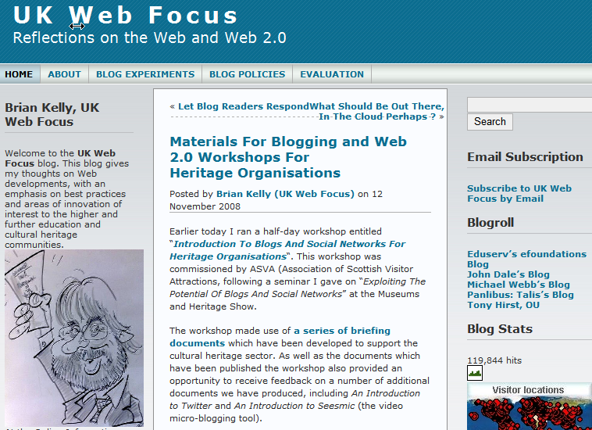

Scope Of The Blog
The main audiences of the blog are those involved in the provision of networked information services, with a particular focus on the provision of Web services in the UK’s higher & further education and the museums, libraries and archives sectors. The blog also seeks to engage with the wider digital library development community.
The UK Web Focus Blog

About The UK Web Focus Blog
The UK Web Focus blog is provided by Brian Kelly, a Web adviser to the UK’s higher and further education community and the cultural heritage sector in England. Brian works for UKOLN, a national centre of expertise in digital information management, located at the University of Bath which is funded by the JISC and the MLA.
The blog is available at the URL <http://ukwebfocus.wordpress.com/>.

Scope Of The Blog
The main audiences of the blog are those involved in the provision of networked information services, with a particular focus on the provision of Web services in the UK’s higher & further education and the museums, libraries and archives sectors. The blog also seeks to engage with the wider digital library development community.

The contents of the blog cover a range of aspects related to the Web and networked information services. This includes Web standards and best practices, Web accessibility and emerging Web technologies. A particular area of interest is in Web 2.0 technologies and their potential within the museums and library sectors.
Topics covered in recent blog [posts include best practices for blogging [1], the potential of micro-blogging tools such as Twitter [2] and accessibility issues [3].

Aims Of The Blog
The main aims of the blog are:
User engagement: The blog seeks to engage the readers if discussion and debate.
Dissemination: The blog provides a mechanism for disseminating information on UK Web Focus activities.
Experimentation: The blog provides a means of carrying out various experiments, such as approaches to blogging and use of blog widgets.
Thinking out loud: The blog enables the author to air speculative thoughts and ideas and to invite responses.

Reflective Blogging
The experiences gained after launching the UK Web Focus blog in November 2006 have been documented on the blog. The blog therefore provides information which will be of interest to organisations which may be considering establishing a blog or enhancing an existing blog service.

Provider of the UK Web Focus Blog
The UK Web Focus blog has a single author – Brian Kelly – who is responsible for the content of the blog, although there are also occasional invited guest blog posts. The blog supports the author’s work as UK Web Focus at the University of Bath, UK.
The blog’s policy [4] and a description of its purpose [5] are provided on the blog.

References
- Blog Posts About Blogging, UK Web Focus blog, <http://ukwebfocus.wordpress.com/category/blog/>
- Twitter Blog Posts, UK Web Focus blog, <http://ukwebfocus.wordpress.com/category/twitter/>
- Accessibility Blog Posts, UK Web Focus blog, <http://ukwebfocus.wordpress.com/category/accessibility/>
- Blog Policies, UK Web Focus blog, <http://ukwebfocus.wordpress.com/blog-policies/>
- Scope, Rationale and Policy for this Blog, UK Web Focus blog, 6 Nov 2007 <http://ukwebfocus.wordpress.com/2006/11/06/scope-rationale-and-policy-for-this-blog/>
The contents of the blog cover a range of aspects related to the Web and networked information services. This includes Web standards and best practices, Web accessibility and emerging Web technologies. A particular area of interest is in Web 2.0 technologies and their potential within the museums and library sectors.
Topics covered in recent blog [posts include best practices for blogging [1], the potential of micro-blogging tools such as Twitter [2] and accessibility issues [3].

Aims Of The Blog
The main aims of the blog are:
User engagement: The blog seeks to engage the readers if discussion and debate.
Dissemination: The blog provides a mechanism for disseminating information on UK Web Focus activities.
Experimentation: The blog provides a means of carrying out various experiments, such as approaches to blogging and use of blog widgets.
Thinking out loud: The blog enables the author to air speculative thoughts and ideas and to invite responses.

Reflective Blogging
The experiences gained after launching the UK Web Focus blog in November 2006 have been documented on the blog. The blog therefore provides information which will be of interest to organisations which may be considering establishing a blog or enhancing an existing blog service.

Provider of the UK Web Focus Blog
The UK Web Focus blog has a single author – Brian Kelly – who is responsible for the content of the blog, although there are also occasional invited guest blog posts. The blog supports the author’s work as UK Web Focus at the University of Bath, UK.
The blog’s policy [4] and a description of its purpose [5] are provided on the blog.

References
- Blog Posts About Blogging, UK Web Focus blog, <http://ukwebfocus.wordpress.com/category/blog/>
- Twitter Blog Posts, UK Web Focus blog, <http://ukwebfocus.wordpress.com/category/twitter/>
- Accessibility Blog Posts, UK Web Focus blog, <http://ukwebfocus.wordpress.com/category/accessibility/>
- Blog Policies, UK Web Focus blog, <http://ukwebfocus.wordpress.com/blog-policies/>
- Scope, Rationale and Policy for this Blog, UK Web Focus blog, 6 Nov 2007 <http://ukwebfocus.wordpress.com/2006/11/06/scope-rationale-and-policy-for-this-blog/>

