
Building A Blogging Community


UKOLN: Supporting The Cultural Heritage Sector

Background
The briefing document provides suggestions on approaches you can take to building a blogging community, including a community of authors and a community of peers.

The Potential Benefits Of A Blogging Community
Blogging is often perceived of as an individual activity. However successful blogs are likely to involve community building, whether this is a community of co-authors, a community of readers or a community of peers.

Team Blogging
The responsibilities of producing regular blog posts over an extended period may be onerous. A solution to this would be to provide a team blog, in which the task of identifying topics of interest, writing the post and responding to comments can be shared. The Archive Hub blog provides an example of this type of approach [1].
It should be noted, though, that a team approach can dilute the ‘voice’ of a blog, and may not be applicable in all cases.

Guest Blog Posts
Another approach to sharing responsibilities for writing posts may be to encourage occasional guest blog posts. This approach has been taken on the UK Web Focus blog [2]. Advantages of guest blog posts include adding variety and a different voice to your blog, providing a forum for others and engaging with new communities.

Blog Widgets To Support Community-Building
Blog widgets enable additional functionality to be provided on your blog. A wide range of blog widgets are available which cover a range of functions. Of relevance to this document are widgets which can support community building. Widgets such as Meebo [3] and TokBox [4] provide realtime text chat and video conferencing facilities for your blog which can help to provide more interactive and engaging services for your blog readers.

Building A Blogging Community

UKOLN: Supporting The Cultural Heritage Sector

Background
The briefing document provides suggestions on approaches you can take to building a blogging community, including a community of authors and a community of peers.

The Potential Benefits Of A Blogging Community
Blogging is often perceived of as an individual activity. However successful blogs are likely to involve community building, whether this is a community of co-authors, a community of readers or a community of peers.

Team Blogging
The responsibilities of producing regular blog posts over an extended period may be onerous. A solution to this would be to provide a team blog, in which the task of identifying topics of interest, writing the post and responding to comments can be shared. The Archive Hub blog provides an example of this type of approach [1].
It should be noted, though, that a team approach can dilute the ‘voice’ of a blog, and may not be applicable in all cases.

Guest Blog Posts
Another approach to sharing responsibilities for writing posts may be to encourage occasional guest blog posts. This approach has been taken on the UK Web Focus blog [2]. Advantages of guest blog posts include adding variety and a different voice to your blog, providing a forum for others and engaging with new communities.

Blog Widgets To Support Community-Building
Blog widgets enable additional functionality to be provided on your blog. A wide range of blog widgets are available which cover a range of functions. Of relevance to this document are widgets which can support community building. Widgets such as Meebo [3] and TokBox [4] provide realtime text chat and video conferencing facilities for your blog which can help to provide more interactive and engaging services for your blog readers.

Engaging With Your Peers
Another approach to community-building is sharing experiences and best practices with one’s peers, such as fellow bloggers who work in the same sector.
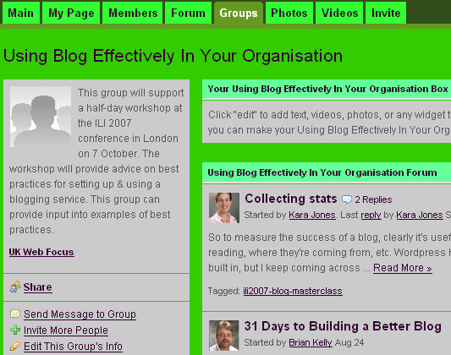
In the information sector this could include participating in mailing lists aimed at the blogging community (such as the lis-bloggers JISCMail list [5]) or participating in social networking services, such as the Library 2.0 Ning group [6] or the Library 2.0 Interest Group Facebook group [7].

Staff Development
An important aspect in the provision of quality blogging services is professional development for those involved in the provision of blog services. Fortunately there are a range of online services available which can be used to improve one’s blogging skills. As well as blogs provided by experienced information professionals [8] and [9] there are online blogging courses, such as the 31 Days project [10].

References
- Archives Hub Blog, Archive Hub blog,
<http://www.archiveshub.ac.uk/blog/>
- Guest Blog Posts, UK Web Focus blog,
<http://ukwebfocus.wordpress.com/tag/blog/guest-post/>
- Meebo - A Follow-Up, UK Web Focus blog, 26 Jan 2007, <http://ukwebfocus.wordpress.com/2007/01/26/meebo-a-follow-up/>
- TokBox - A Useful Video-Conferencing Tool Or Something Sinister?, UK Web Focus blog, 19 Sep 2007, <http://ukwebfocus.wordpress.com/2007/09/19/tokbox-a-useful-video-conferencing-tool-or-something-sinister/>
- lis-bloggers, JISCMail, <http://www.jiscmail.ac.uk/lists/LIS-BLOGGERS.html>
- Library 2.0, Ning, <http://library20.ning.com/>
- Library 2.0 Interest Group, Facebook, <http://bathac.facebook.com/group.php?gid=2212848798>
- Phil Bradley’s Blog, <http://www.philbradley.typepad.com/>
- Tame The Web blog, Michael Stephens, <http://tametheweb.com/>
- 31 Days to a Building Better Blog Challenge, The Bamboo Project, <http://michelemartin.typepad.com/thebambooprojectblog/join-the-31-days-to-build.html>

Engaging With Your Peers
Another approach to community-building is sharing experiences and best practices with one’s peers, such as fellow bloggers who work in the same sector.
In the information sector this could include participating in mailing lists aimed at the blogging community (such as the lis-bloggers JISCMail list [5]) or participating in social networking services, such as the Library 2.0 Ning group [6] or the Library 2.0 Interest Group Facebook group [7].

Staff Development
An important aspect in the provision of quality blogging services is professional development for those involved in the provision of blog services. Fortunately there are a range of online services available which can be used to improve one’s blogging skills. As well as blogs provided by experienced information professionals [8] and [9] there are online blogging courses, such as the 31 Days project [10].

References
- Archives Hub Blog, Archive Hub blog,
<http://www.archiveshub.ac.uk/blog/>
- Guest Blog Posts, UK Web Focus blog,
<http://ukwebfocus.wordpress.com/tag/blog/guest-post/>
- Meebo - A Follow-Up, UK Web Focus blog, 26 Jan 2007, <http://ukwebfocus.wordpress.com/2007/01/26/meebo-a-follow-up/>
- TokBox - A Useful Video-Conferencing Tool Or Something Sinister?, UK Web Focus blog, 19 Sep 2007, <http://ukwebfocus.wordpress.com/2007/09/19/tokbox-a-useful-video-conferencing-tool-or-something-sinister/>
- lis-bloggers, JISCMail, <http://www.jiscmail.ac.uk/lists/LIS-BLOGGERS.html>
- Library 2.0, Ning, <http://library20.ning.com/>
- Library 2.0 Interest Group, Facebook, <http://bathac.facebook.com/group.php?gid=2212848798>
- Phil Bradley’s Blog, <http://www.philbradley.typepad.com/>
- Tame The Web blog, Michael Stephens, <http://tametheweb.com/>
- 31 Days to a Building Better Blog Challenge, The Bamboo Project, <http://michelemartin.typepad.com/thebambooprojectblog/join-the-31-days-to-build.html>

