
An Introduction
To OPML


UKOLN: Supporting The Cultural Heritage Sector

What Is OPML?
OPML is described in Wikipedia as “an XML format for outlines” [1]. OPML stands for Outline Processor Markup Language. It was originally developed as an outlining application by Radio Userland. However it has been adopted for a range of other applications, in particular providing an exchange format for RSS.

Why The Interest?

Grouping Feeds
As an example of the user benefits which OPML can provide let us look at the various RSS feeds which are available on the BBC Web site. These include RSS feeds for:
- News items • Sports
- TV programmes • Regional items
- Podcasts • etc.
In each of these areas there might be multiple additional feeds. For example the Sports feed could provide general news covering all sports, with additional categories for individual sports. Then might then be news feeds for individuals sports teams.
OPML provides a mechanism for grouping related RSS feeds, allowing them to be processed collectively rather than individually. This can be particularly useful if you wish to subscribe to a group of feeds. An example of how the BBC make use of OPML files for their podcasts can be seen at [2].

Export and Import of Feeds
OPML can also be used if you wish to migrate your feeds from one RSS reader/aggregator to another.

User Interface to Resources
An embedded OPML viewer can be used to provide rapid access to resources, avoiding the need to follow presentational navigational aids. An example of this, which makes use of the Grazr OPML viewer, can be seen at [3].
An Introduction
To OPML

UKOLN: Supporting The Cultural Heritage Sector

What Is OPML?
OPML is described in Wikipedia as “an XML format for outlines” [1]. OPML stands for Outline Processor Markup Language. It was originally developed as an outlining application by Radio Userland. However it has been adopted for a range of other applications, in particular providing an exchange format for RSS.

Why The Interest?

Grouping Feeds
As an example of the user benefits which OPML can provide let us look at the various RSS feeds which are available on the BBC Web site. These include RSS feeds for:
- News items • Sports
- TV programmes • Regional items
- Podcasts • etc.
In each of these areas there might be multiple additional feeds. For example the Sports feed could provide general news covering all sports, with additional categories for individual sports. Then might then be news feeds for individuals sports teams.
OPML provides a mechanism for grouping related RSS feeds, allowing them to be processed collectively rather than individually. This can be particularly useful if you wish to subscribe to a group of feeds. An example of how the BBC make use of OPML files for their podcasts can be seen at [2].

Export and Import of Feeds
OPML can also be used if you wish to migrate your feeds from one RSS reader/aggregator to another.

User Interface to Resources
An embedded OPML viewer can be used to provide rapid access to resources, avoiding the need to follow presentational navigational aids. An example of this, which makes use of the Grazr OPML viewer, can be seen at [3].

Examples

User Interface to Resources
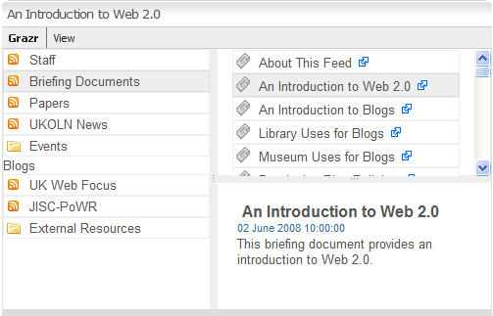
Use of the Grazr widget on the UKOLN Cultural Heritage Web site [3] is illustrated. RSS feeds have been created for the briefing documents and other lists of resources. These RSS feeds are described in an OPML file. The Grazr widget then allows these files to be navigated and once a suitable resource has been found it can be opened in the Web browser window.

Feedreader and Google Reader
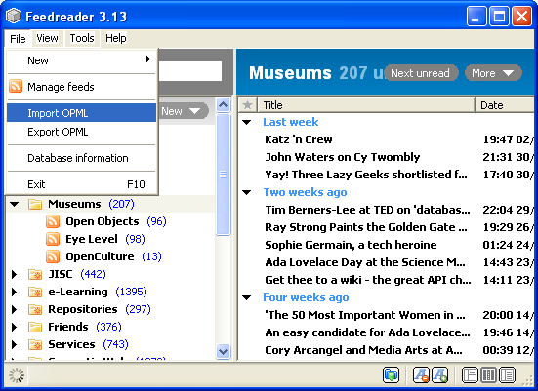
As illustrated, RSS readers such as Feedreader allow RSS files to be imported and exported as OPML files.
This can be useful if you wish to migrate large numbers of RSS feeds from one RSS reader to another.
This may also be useful if you wish to share your list of RSS feeds with other users.
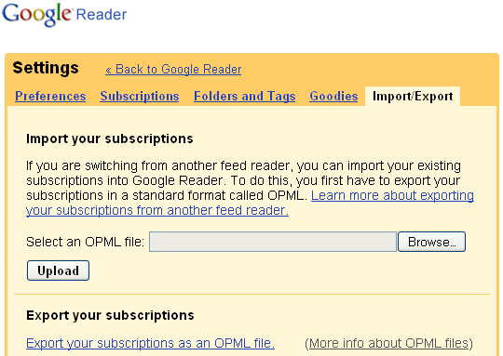
An example of a similar interface in the Google Reader is also illustrated.
The ability to easily migrate data between applications not only provides greater flexibility for the user, it also minimises risks of data being trapped into a particular application.

References
- OPML, Wikipedia, <http://en.wikipedia.org/wiki/OPML>
- OPML feed of podcasts, BBC, <http://www.bbc.co.uk/blogs/radiolabs/2008/04/opml_feed_of_podcasts.shtml>
- RSS Feeds, Cultural Heritage, UKOLN, <http://www.ukoln.ac.uk/cultural-heritage/rss/>

Examples

User Interface to Resources
Use of the Grazr widget on the UKOLN Cultural Heritage Web site [3] is illustrated. RSS feeds have been created for the briefing documents and other lists of resources. These RSS feeds are described in an OPML file. The Grazr widget then allows these files to be navigated and once a suitable resource has been found it can be opened in the Web browser window.

Feedreader and Google Reader
As illustrated, RSS readers such as Feedreader allow RSS files to be imported and exported as OPML files.
This can be useful if you wish to migrate large numbers of RSS feeds from one RSS reader to another.
This may also be useful if you wish to share your list of RSS feeds with other users.
An example of a similar interface in the Google Reader is also illustrated.
The ability to easily migrate data between applications not only provides greater flexibility for the user, it also minimises risks of data being trapped into a particular application.

References
- OPML, Wikipedia, <http://en.wikipedia.org/wiki/OPML>
- OPML feed of podcasts, BBC, <http://www.bbc.co.uk/blogs/radiolabs/2008/04/opml_feed_of_podcasts.shtml>
- RSS Feeds, Cultural Heritage, UKOLN, <http://www.ukoln.ac.uk/cultural-heritage/rss/>

